Management Control System

Software Training Materials

**Table of Contents**

1. INTRODUCTION OF MANAGEMENT CONTROL SYSTEM 5

How to Log in the MCS 5

2. FINANCE & ACCOUNTS WING 6

3. ACCOUNTS & BUDGET MANAGEMENT (SUB MODULE) 7

4.ACCOUNTS & BUDGET MANAGEMENT MENUS OVERVIEW 9

4.1: Settings Menu Overview 10

4.1.1.1: Chart of Account Code (Settings) Add Account Code input field 10

4.1.1.2: Chart of Account Code (Settings) View of details 12

4.1.1.3: Chart of Account Code (Settings) Download All 14

4.1.2.1: Chart of GoB Code (Settings) Add GoB Code input field 15

4.1.2.2: Chart of GoB Code (Settings) View of details 15

4.1.2.3: Chart of GoB Code (Settings) Edit Input Field 16

4.1.2.4: Chart of GoB Code (Settings) Delete 16

4.1.2.5: Chart of GoB Code (Settings) Search 17

4.1.3.1: Bank Account (Settings) Add Bank Account 18

4.1.3.2: Bank Account (Settings) View of details( Bank list for finance & Accounts) 19

4.1.3.3: Bank Account (Settings) Search 23

4.1.4.1: BBA Wings (Settings) BBA Wings view 24

4.1.5.1: Supp/Cons/Contractor (Settings) Add Data (Supplier,Consultant,Contractor) Input Field 25

4.1.5.2: Supp/Cons/Contractor (Settings) View of details 26

4.1.5.3: Supp/Cons/Contractor (Settings) Add Supplier type Input Field 27

4.1.5.4: Supp/Cons/Contractor (Settings) View Details of Add Supplier type 27

4.1.5.4.1: Supp/Cons/Contractor (Settings) Add Supplier type Edit 28

4.1.5.4.2: Supp/Cons/Contractor (Settings) Add Supplier type Delete 28

4.1.5.5: Supp/Cons/Contractor (Settings) Edit Input Field 29

4.1.5.6: Supp/Cons/Contractor (Settings) Delete 29

4.1.5.7: Supp/Cons/Contractor (Settings) Search 30

4.1.6.1: Service (Settings) Add New Service 31

4.1.6.2: Service (Settings) View of service list details 31

4.1.6.3: Service (Settings) Edit Input Field 32

4.1.6.4: Service (Settings) Delete 33

4.1.6.5: Service (Settings) Search 33

4.1.7.1: Projects (Settings) Add Project input field 34

4.1.7.2: Projects (Settings) View details of project list 35

4.1.7.3: Projects (Settings) Edit 35

4.1.7.4: Projects (Settings) Delete 36

4.1.7.5: Projects (Settings) Search 37

4.1.8.1: Currency Converter (Settings) Currency Converter input field 38

4.2: Budgets Menu Overview 39

4.2.1.1: Budget Entry (Budgets) Budget Entry input field 39

4.2.1.2: Budget Entry (Budgets) View of Budget Entry Data 40

4.2.2.1: Manage Budget (Budgets) View all budget info (Year Wage) 40

4.2.2.2: Manage Budget (Budgets) View of single budget info 41

4.2.2.2.1: Manage Budget (Budgets) View of single budget info (Edit) 42

4.2.2.2.2: Manage Budget (Budgets) View of single budget info (Delete) 43

4.2.2.3: Manage Budget (Budgets) Search 44

4.2.3.1: Expense Entry (Budgets) Expense Entry input field 44

4.2.4.1: Manage Expenses (Budgets) View details of budget expenses information 45

4.2.4.2.1: Manage Expenses (Budgets) Single budget expenses information 46

4.2.4.2.2: Manage Expenses (Budgets) View details of budget expenses information(Print) 46

4.2.5.1: Report (Budgets) Search all allocated budget sector 47

4.2.5.1.1: Report (Budgets) Search all allocated budget sector(Download excel file) 48

4.2.5.2: Report (Budgets) Search all expenses (from allocated budget sector) 49

4.3: Voucher Menu Overview 50

4.3.1.1: Entry (Voucher) Voucher entry form 50

4.3.1.2: Manage (Voucher) View Single voucher Details 51

4.3.2.1: Manage (Voucher) View Voucher Information 51

4.3.2.2: Manage (Voucher) Single voucher details information 51

4.3.2.3: Manage (Voucher) delete 54

4.3.2.4: Manage (Voucher) Unpost 55

4.3.2.5: Manage (Voucher) Voucher search 55

4.3.3.1: Old Records (Voucher) Search old voucher input form 57

4.4: Ledgers Menu Overview 58

4.4.1.1: General Ledger (Ledgers) Generate general ledger input form 59

4.4.2.1: Subsidiary Ledger (Ledgers) Generate subsidiary ledger input form 60

4.4.3.1: Bank Ledger (Ledgers) Generating Bank ledger input form 60

4.5: Bank Reconciliation Menu Overview 61

4.5.2.1: View Statement (Bank Reconciliation) generate bank statement 62

4.5.3.1: Generate (Bank Reconciliation) Generating bank reconciliation 63

4.6: Assets Depreciation Menu Overview 65

4.6.1.1: Annexure-A (Assets Depreciation) View Annexure-A data 65

4.6.2.1: Annexure-B (Assets Depreciation) View Annexure-B data 66

4.7: Trail Balance Menu Overview 67

4.7.1.1: (Trail Balance) Trail Balance input form & Result 67

4.8: Income & Expense Menu Overview 68

4.8.1.1: (Income & Expense) Income & Expense report generating input form & Result 68

4.9: Balance Sheet Menu Overview 69

4.9.1.1: (Balance Sheet) Generate balance sheet report input form & result 69

4.10: Cash Flow Menu Overview 70

4.10.1: (Cash Flow) View cash flow data 71

# 1. INTRODUCTION OF MANAGEMENT CONTROL SYSTEM

……….

….

…….

…….

…….

Link for MCS is <http://192.168.3.7:3000/> which is accessible within BBA’s local network . After search will open a login page. Which is like –

### How to Log in the MCS

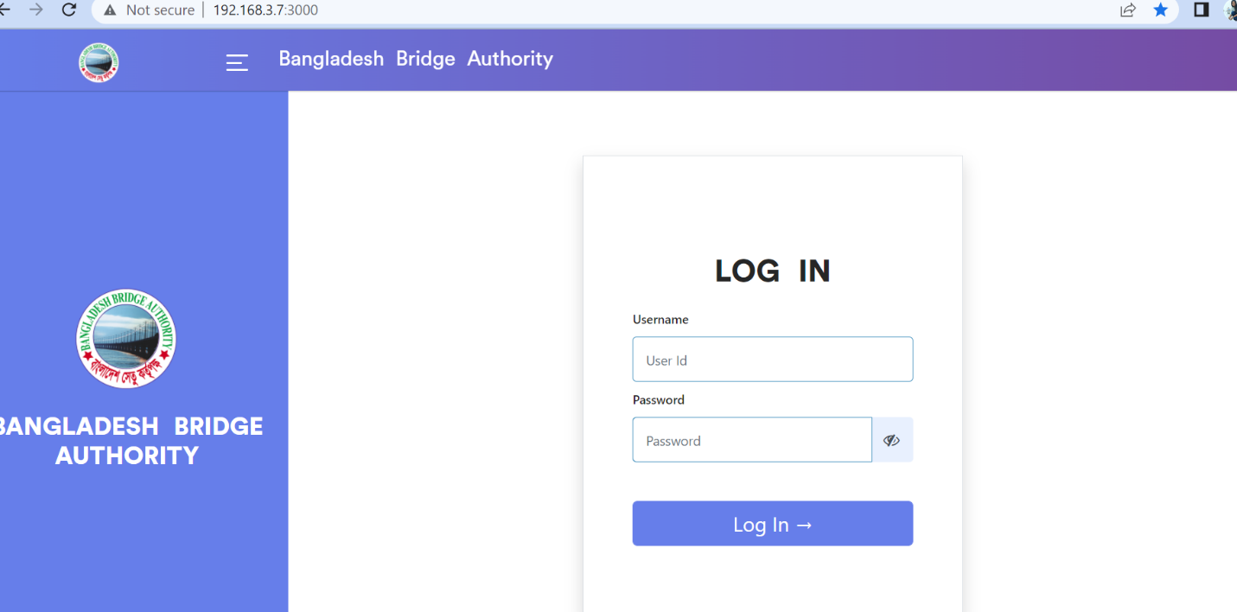

Figure 1: Log in Page

**Steps to Log in MCS**

1. User will input his Username
2. User will input his Password
3. Click Log In Button

If the username & password are correct, users will get access into the system.

# 2. FINANCE & ACCOUNTS WING

For Finance & Accounts module –

**Steps to Enter in Finance & Accounts**

1. After login will show this dashboard of MCS.

2. Click on the Finance & Accounts.

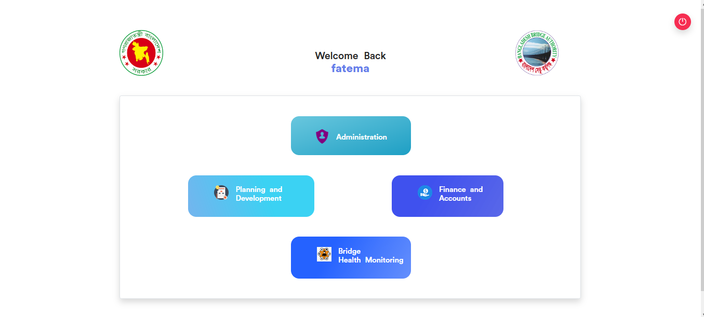

Figure 2.1: Dashboard of MCS

After entering into Finance & Accounts then there will show another dashboard with another four (4) Submodules. Such as-

1.Accounts & Budget Management

2.MIS Payroll Management

3.FDR Management

4.CPF Management

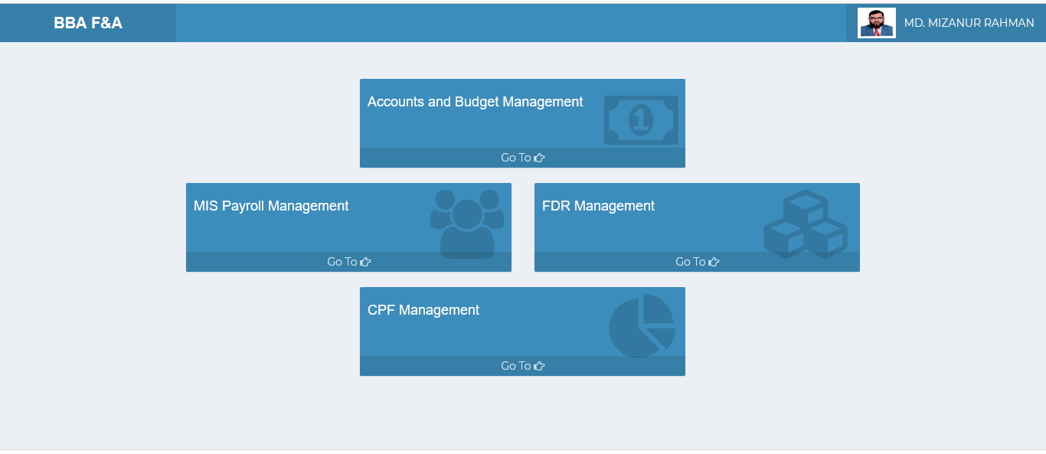

Figure 2.2: Dashboard of Finance & accounts Module.

**Overview of Finance & Accounts Sub Modules**

# 3. ACCOUNTS & BUDGET MANAGEMENT (SUB MODULE)

After clicking into Accounts and budget Management, it will redirect to the (Accounts & Budget Sub Module) dashboard with some menus.

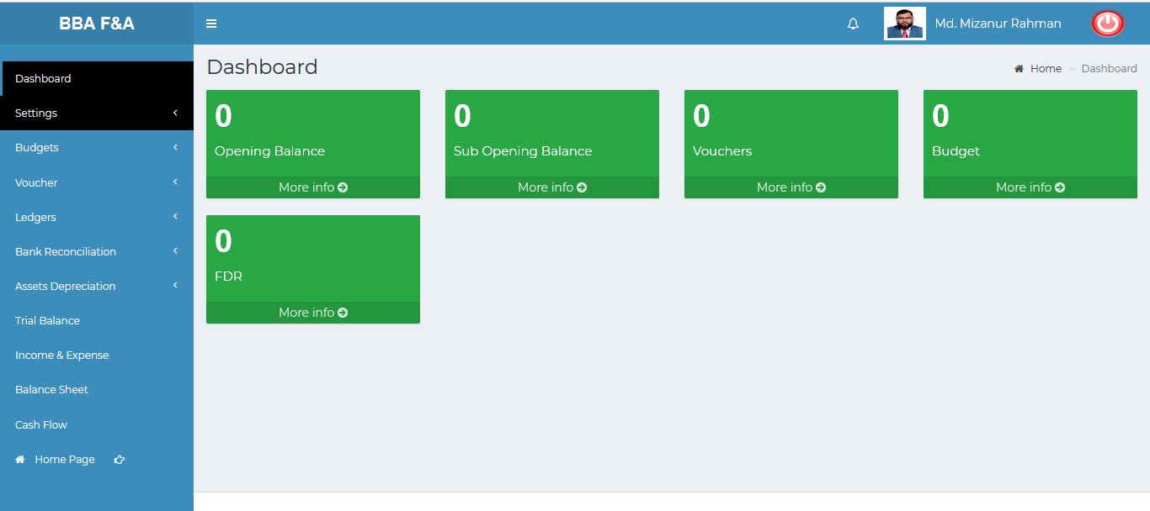

Figure 3: Dashboard of accounts & budget (sub module).

There are five segments on the right side of the Accounts & Budget Management Dashboard Such as **Opening Balance** ,**Sub Opening balance** ,**Vouchers, Budget** and **FDR.**

To get the details info about (**Opening Balance, Sub Opening Balance, Vouchers, Budget,FDR**) just click on the More info link after that it will redirect to relevant details info page.

# 4.ACCOUNTS & BUDGET MANAGEMENT MENUS OVERVIEW

**Accounts & Budget Management Menus Overview**

## 4.1: Settings Menu Overview

**Overview of Settings**

Click on the settings menu after that there will appear eight(08) sub-menu & they are **Chart of Account Code**, **Chart of GoB code, Bank Account** ,**BBA Wings** , **Projects** ,**Supp/Cons/Contractor** ,**Service, Currency Converter.**

### 4.1.1.1: Chart of Account Code (Settings) Add Account Code input field

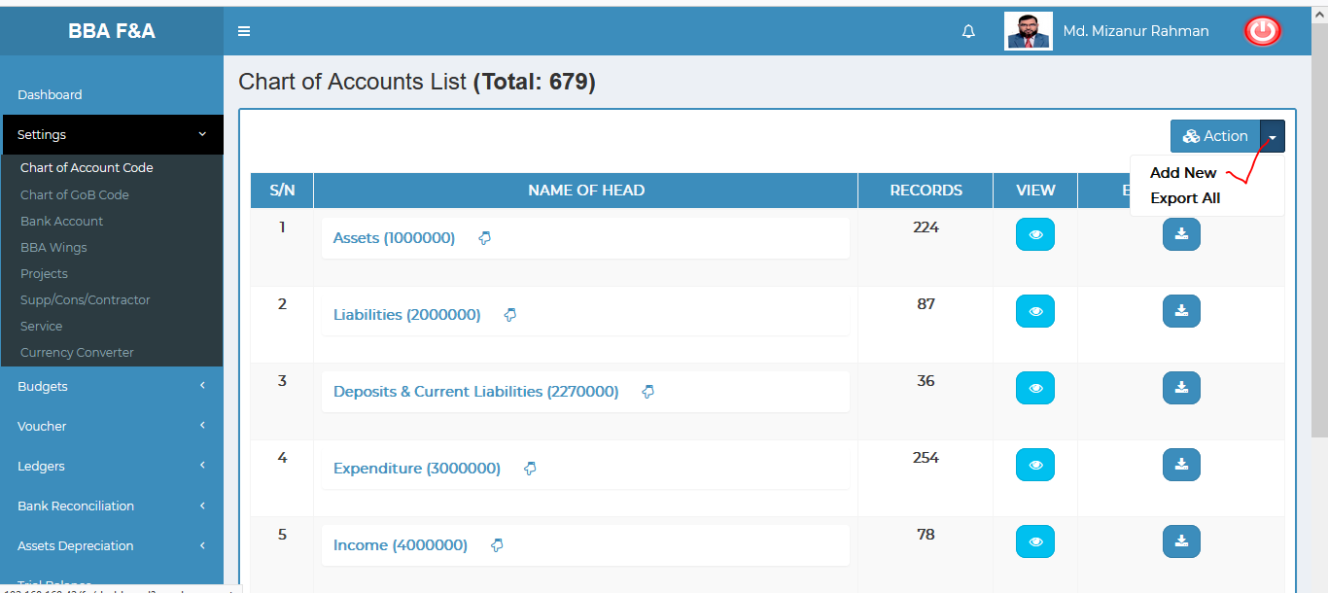

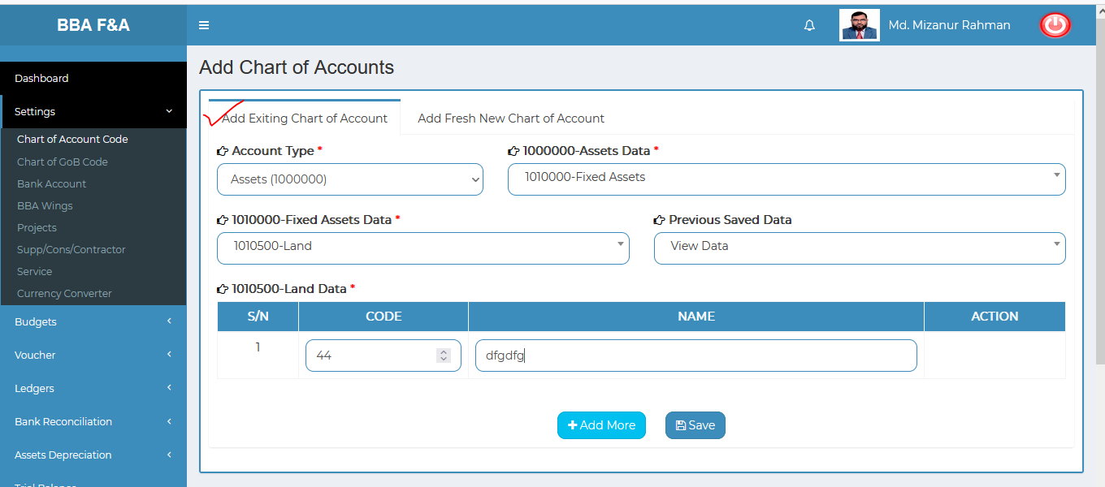

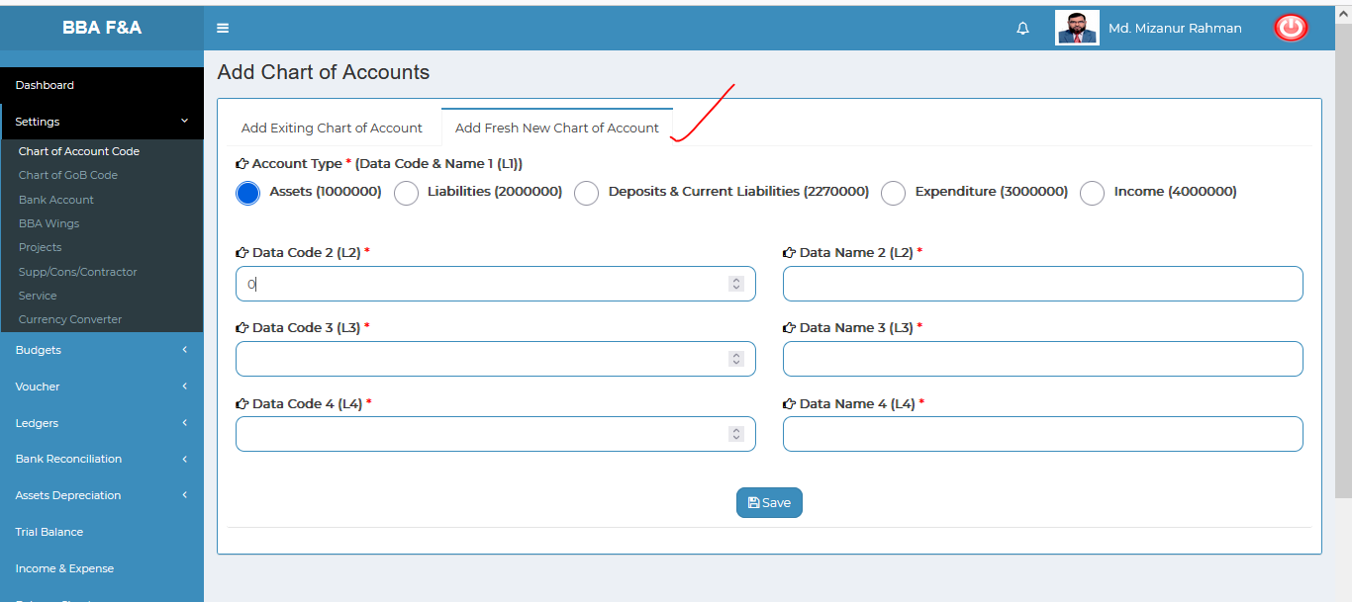

Figure 4.1.1.1: chart of account code(settings)add account code input field

### 4.1.1.2: Chart of Account Code (Settings) View of details

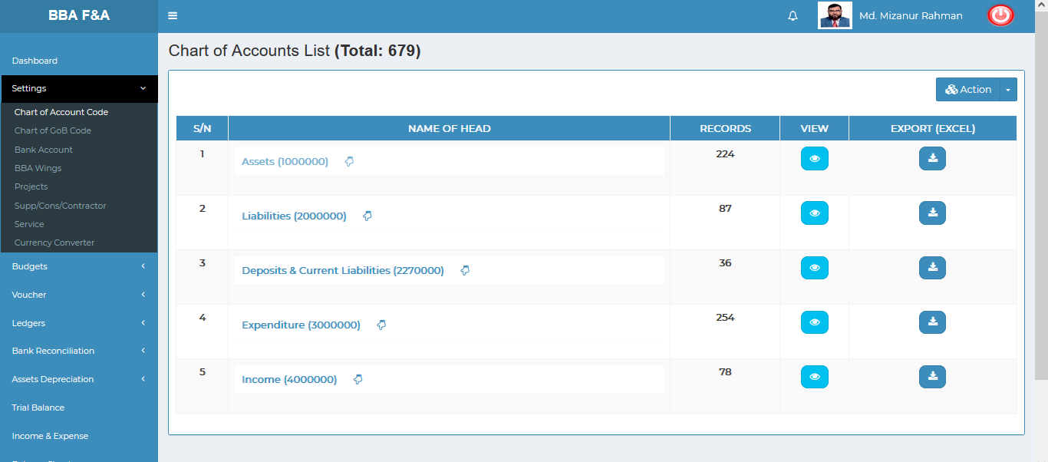

For Exmaple, if the user wants to know about assets just click on the (Assets) arrow thumb and looks like information will display

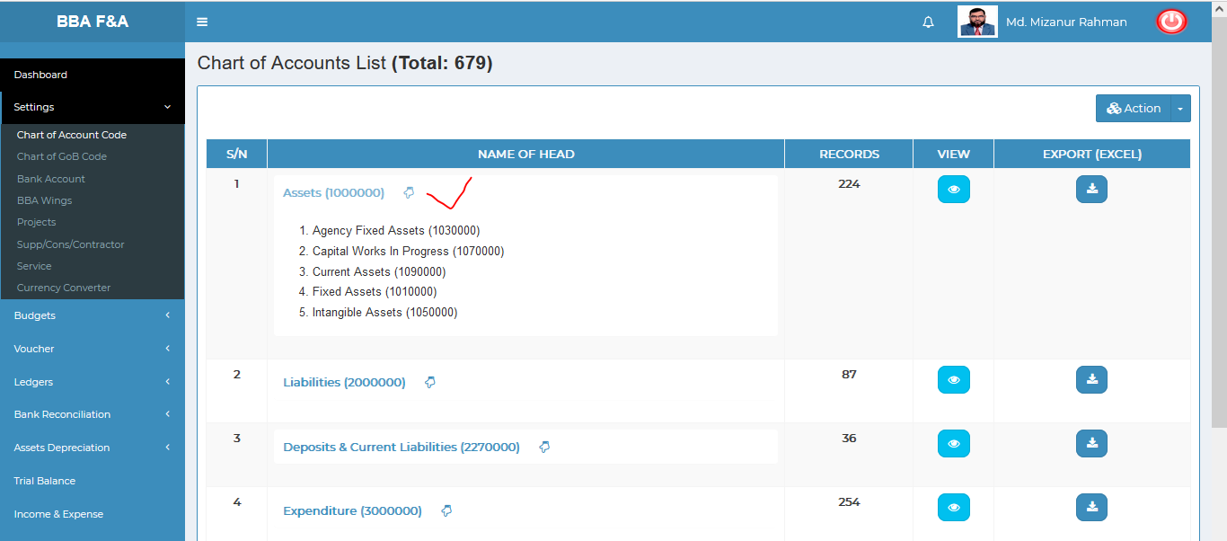

To know details about single assets information ,click on the view button then it will redirect to **Assets Account List** page which is look like the below scenario.

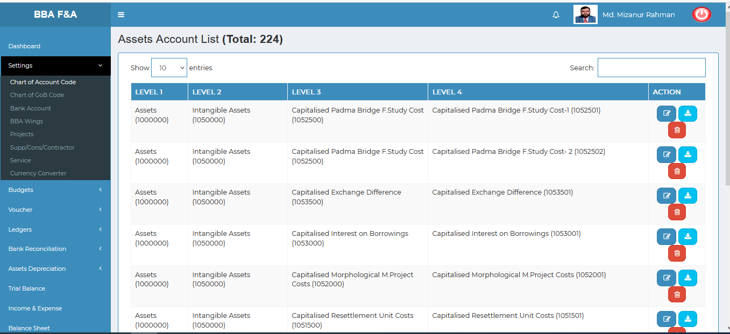

In the **Assets Account List Page** user can **edit**, **delete,Search** and **download-(** excel file which is the same categories lavel-2 data).

Figure 4.1.1.2: chart of account code(settings)View of details

### 4.1.1.3: Chart of Account Code (Settings) Download All

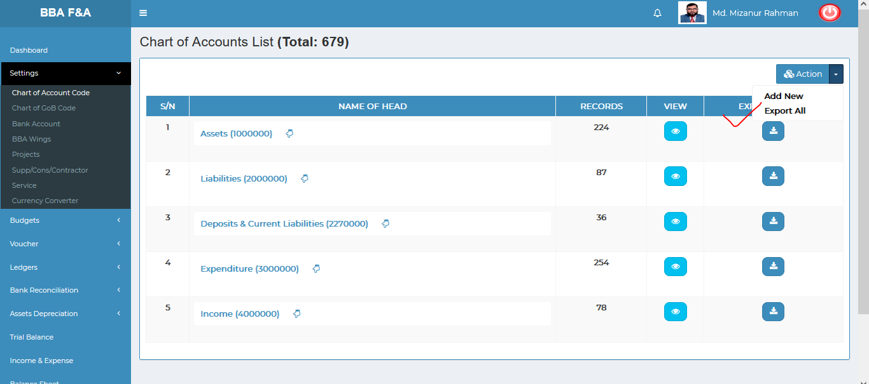

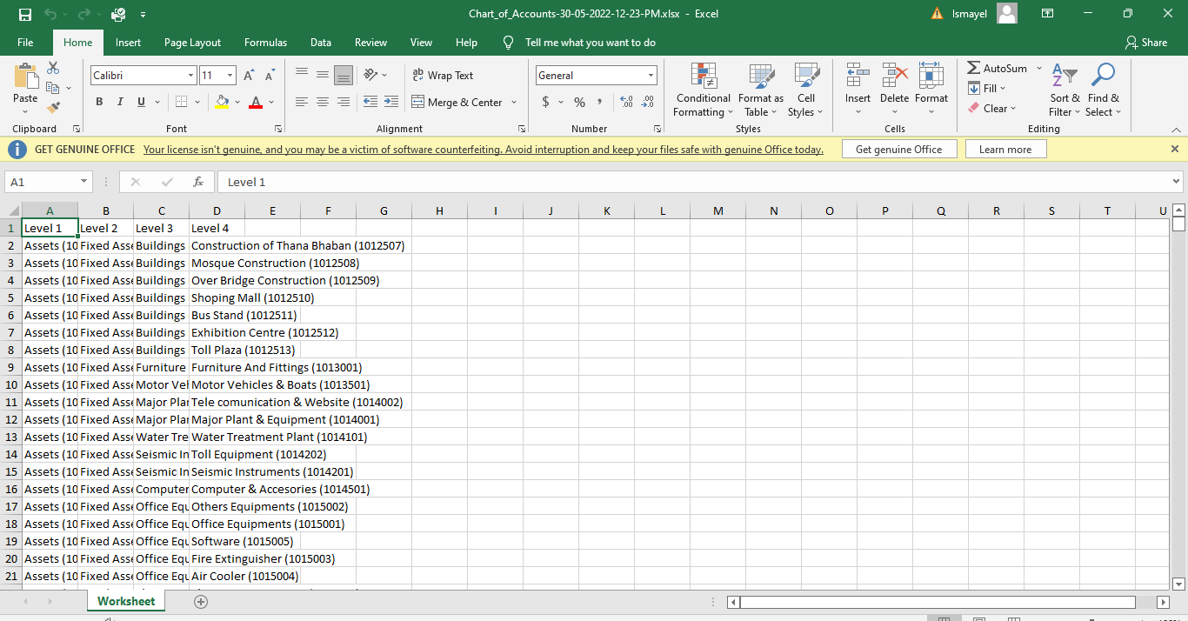

Figure 4.1.1.3: chart of account code(settings)download all

### 4.1.2.1: Chart of GoB Code (Settings) Add GoB Code input field

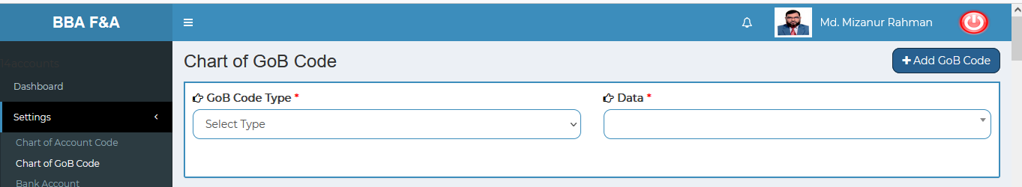

Figure 4.1.2.1: chart of gob code(settings)add gob code input field

### 4.1.2.2: Chart of GoB Code (Settings) View of details

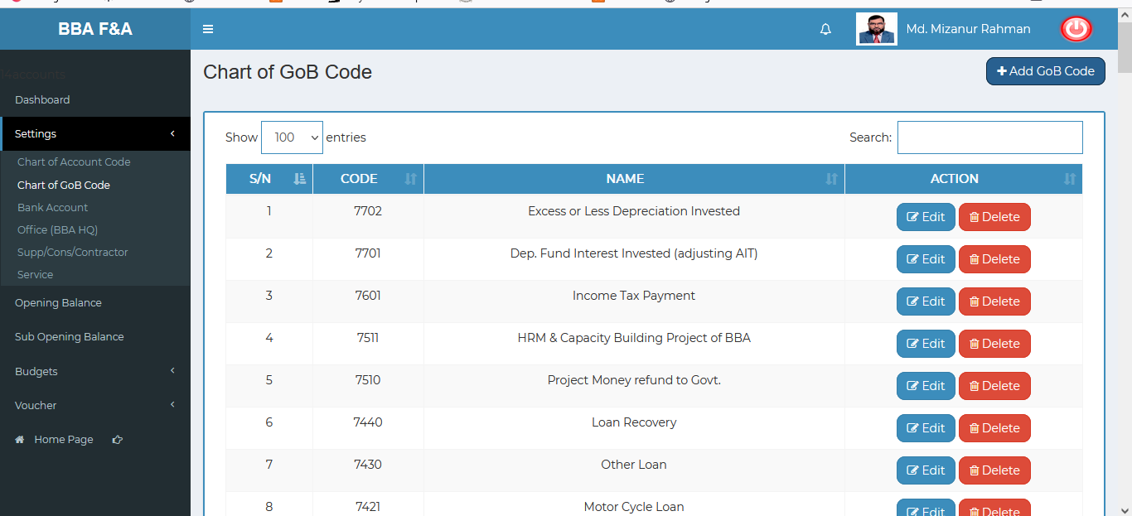

Figure 4.1.2.2: chart of Gob code(settings)View of details

### 4.1.2.3: Chart of GoB Code (Settings) Edit Input Field

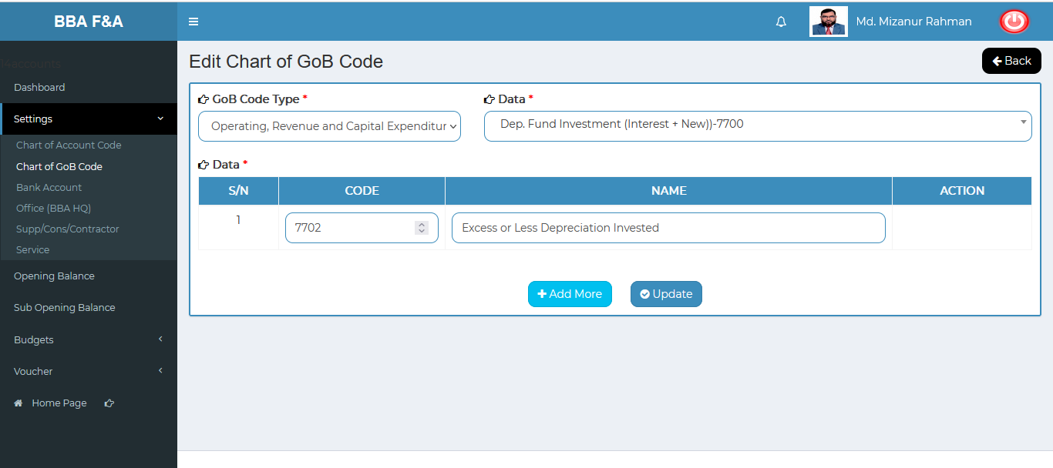

Figure 4.1.2.3: chart of GoB code (settings) Update input field

### 4.1.2.4: Chart of GoB Code (Settings) Delete

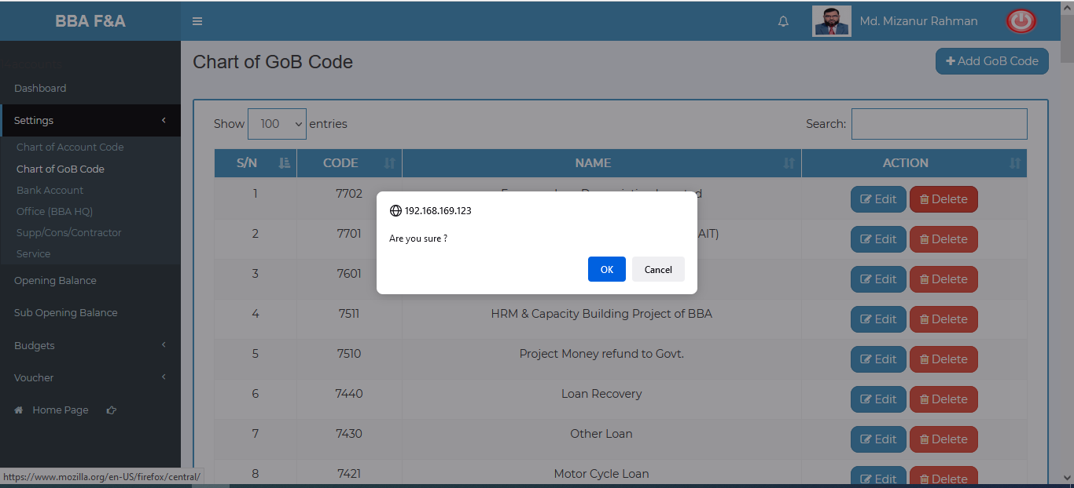

Figure 4.1.2.4: chart of GoB code(settings)delete

### 4.1.2.5: Chart of GoB Code (Settings) Search

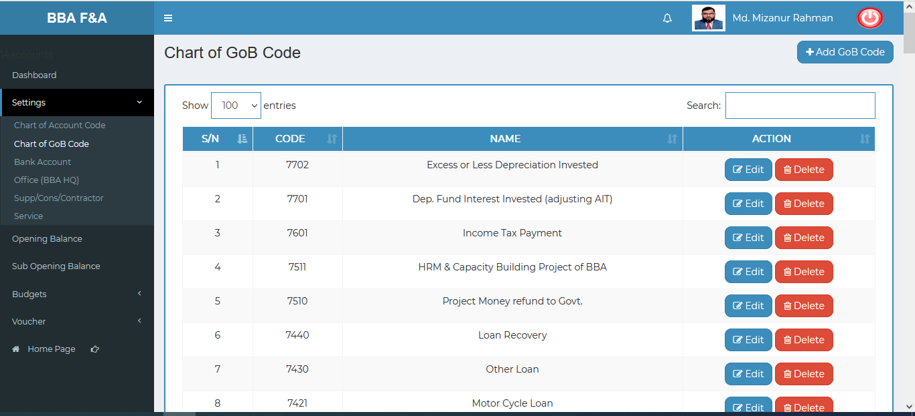

Figure 4.1.2.5: chart of GoB code(settings)before search

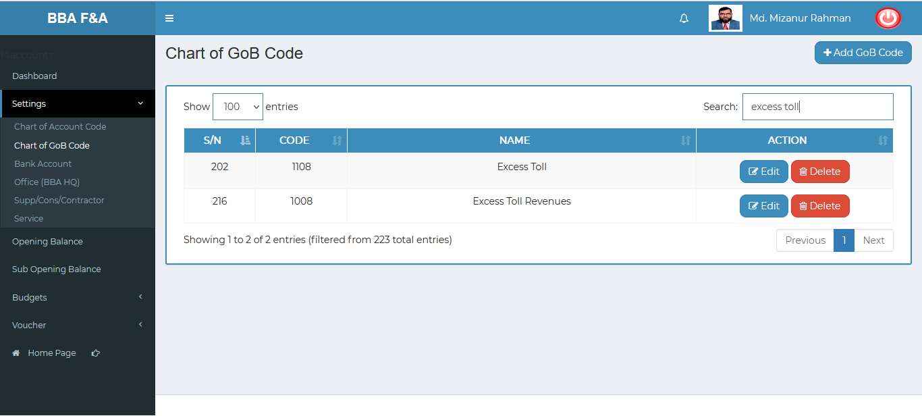

Figure 4.1.2.5: chart of GoB code(settings)after search

### 4.1.3.1: Bank Account (Settings) Add Bank Account

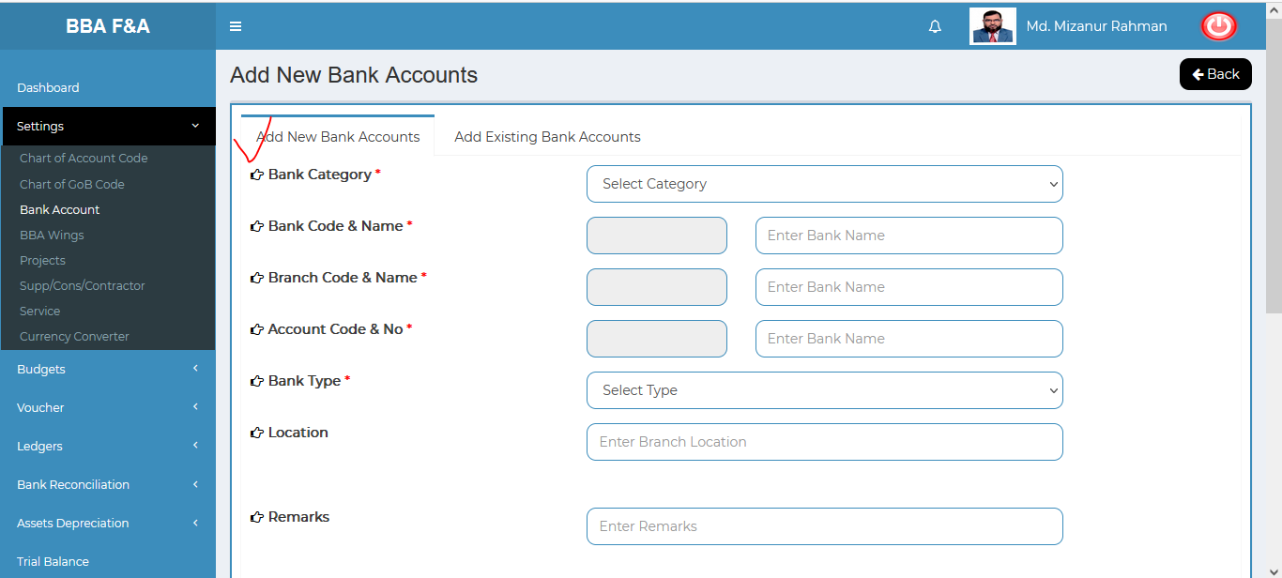

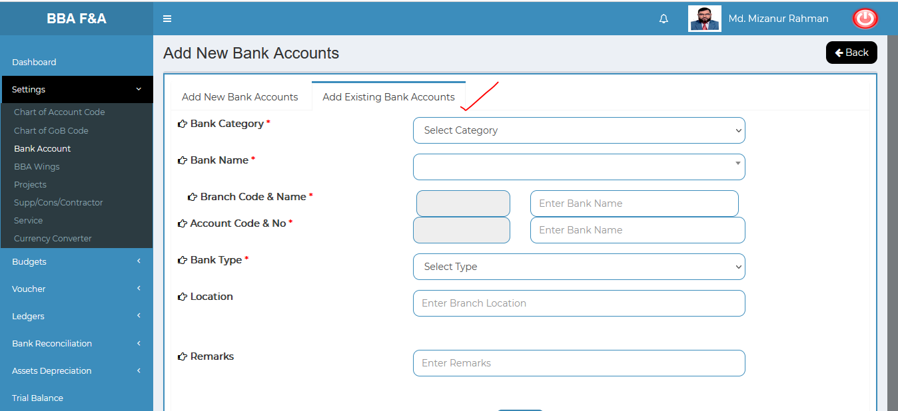

Figure 4.1.3.1: Bank account (settings)add bank account input field(New & Existing)

### 4.1.3.2: Bank Account (Settings) View of details( Bank list for finance & Accounts)

**Fixed Deposits**: Click on the view info to see the branch list of bank. User can update ,delete bank & branch name. . User can also see the data in pdf format & print out it.

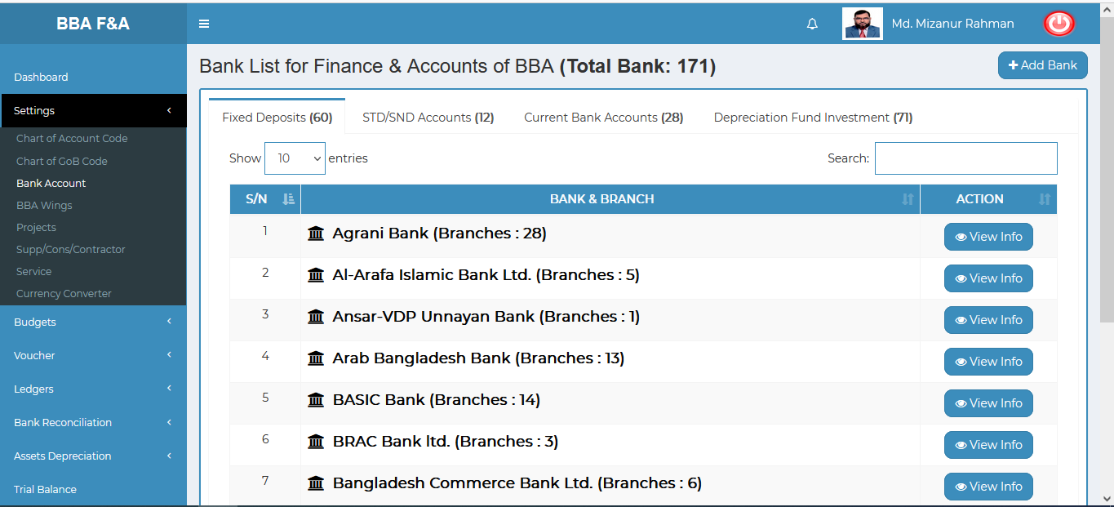

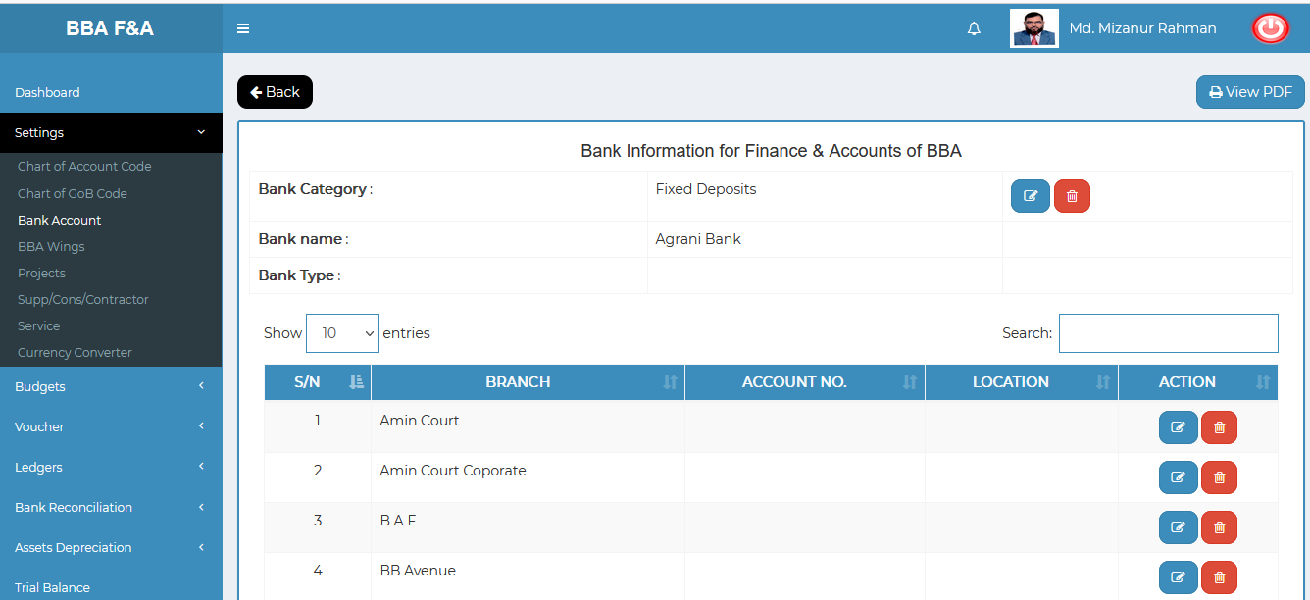

Figure: fixed deposits Bank & branch list

**STD/SND ACCOUNTS**: Click on the view info to see the specific branch list of bank. User can update ,delete bank & branch name. . User can also see the data in pdf format & print out it.

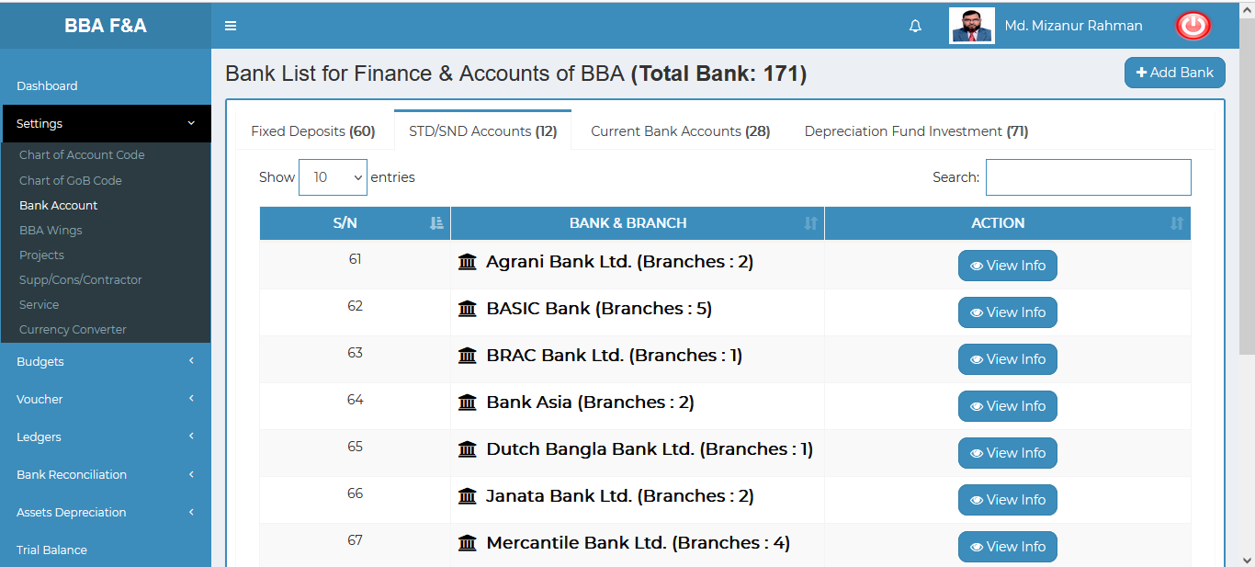

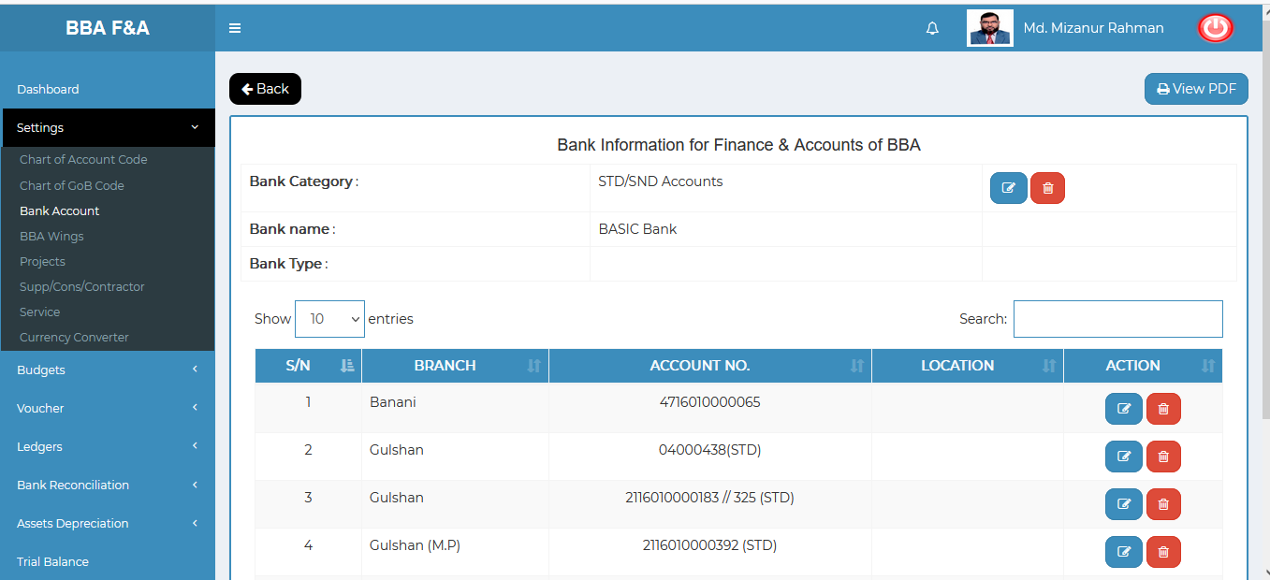

Figure: std/snd accounts Bank & branch list

**CURRENT BANK ACCOUNT**: Click on the view info to see the specific bank branch list. User can update ,delete bank & branch name. . User can also see the data in pdf format & print out it.

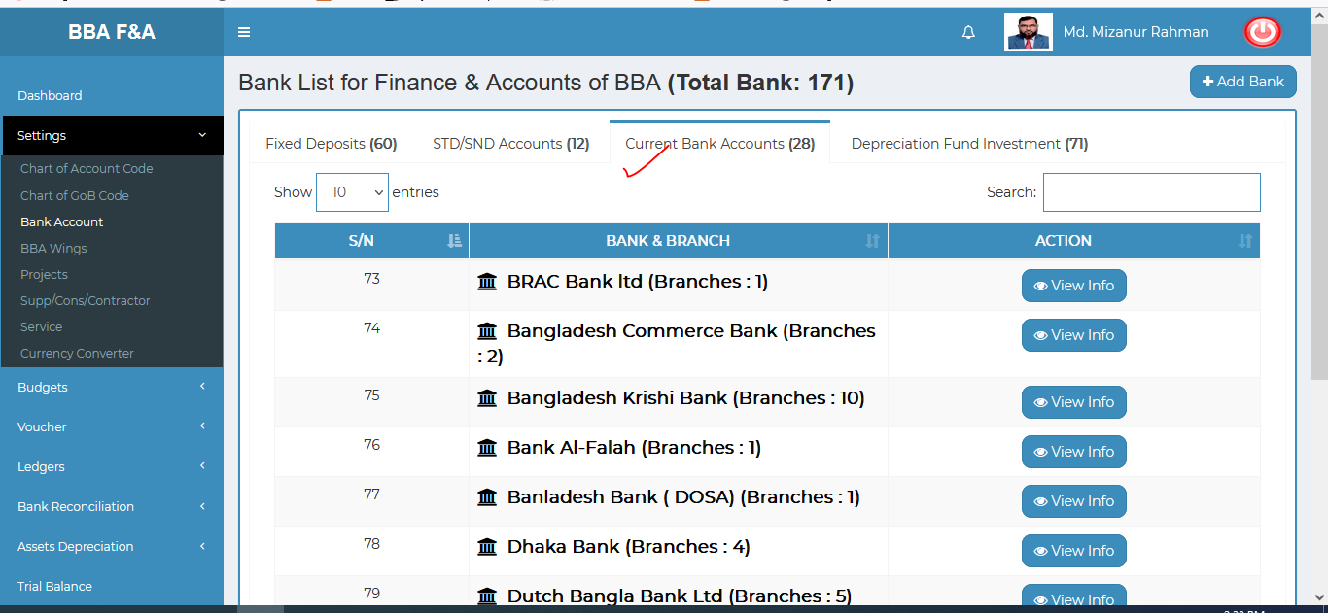

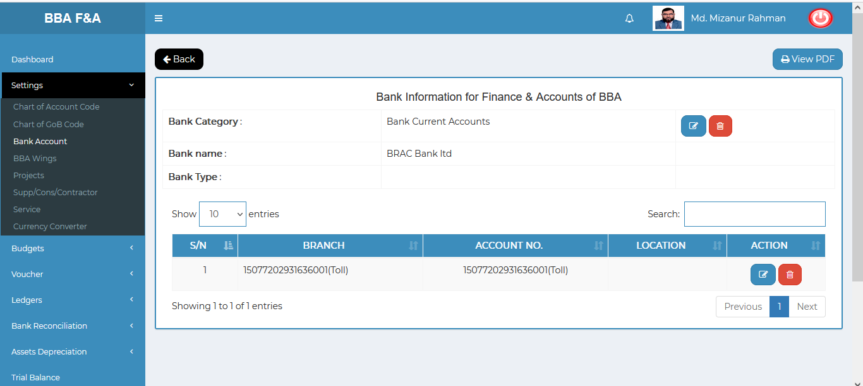

Figure: CURRENT BANK ACCOUNT Bank & branch list

**DEPRECIATION FUND INVESTMENT**: Click on the view info to see the specific bank branch list. User can update ,delete bank & branch name. User can also see the data in pdf format & print out it.

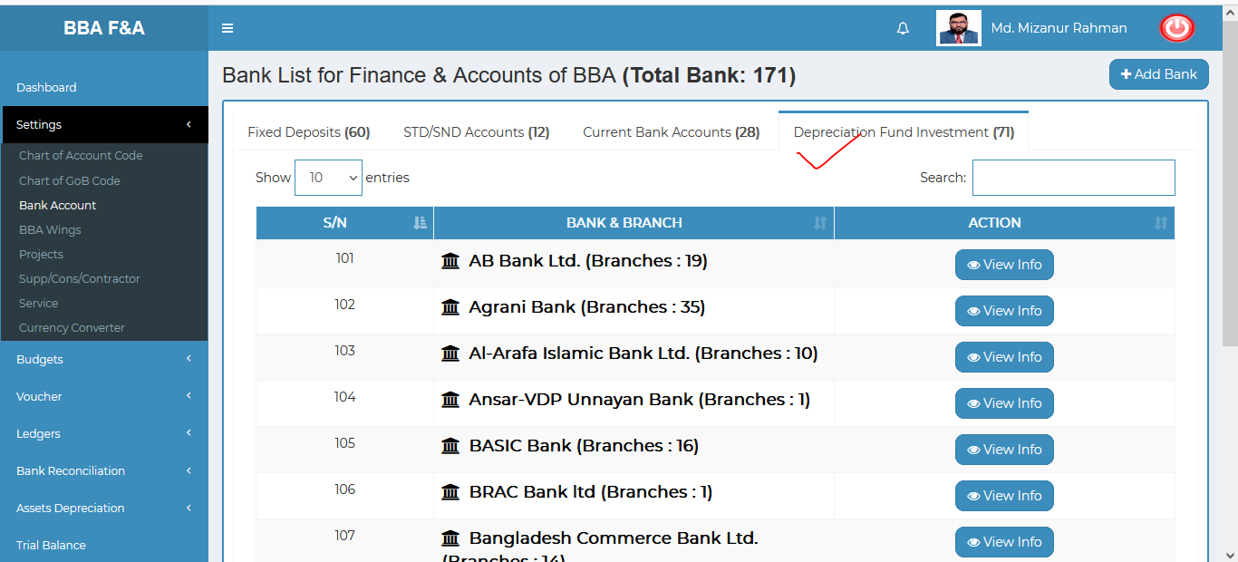

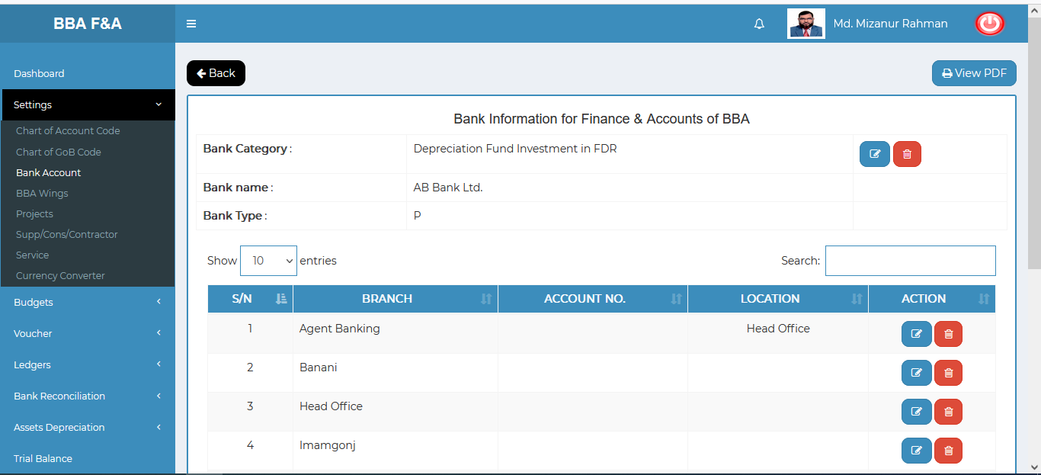

Figure: depreciation fund investment Bank & branch list

Figure 4.1.3.2: Bank Account (settings) View of details(bank list for finance & accounts)

### 4.1.3.3: Bank Account (Settings) Search

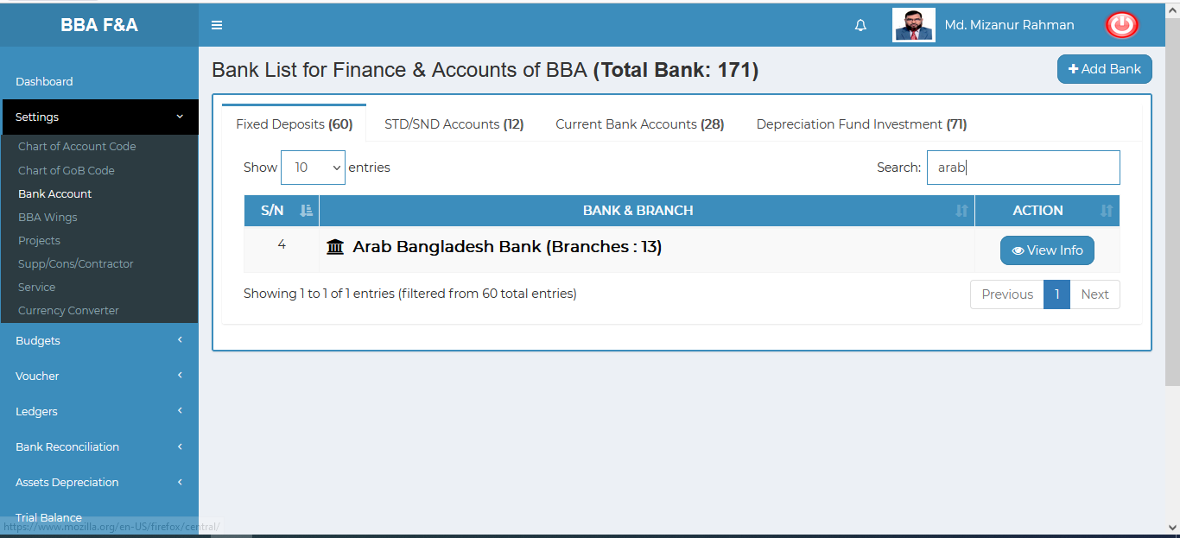

Figure 4.1.3.5: Bank account (settings) search

### 4.1.4.1: BBA Wings (Settings) BBA Wings view

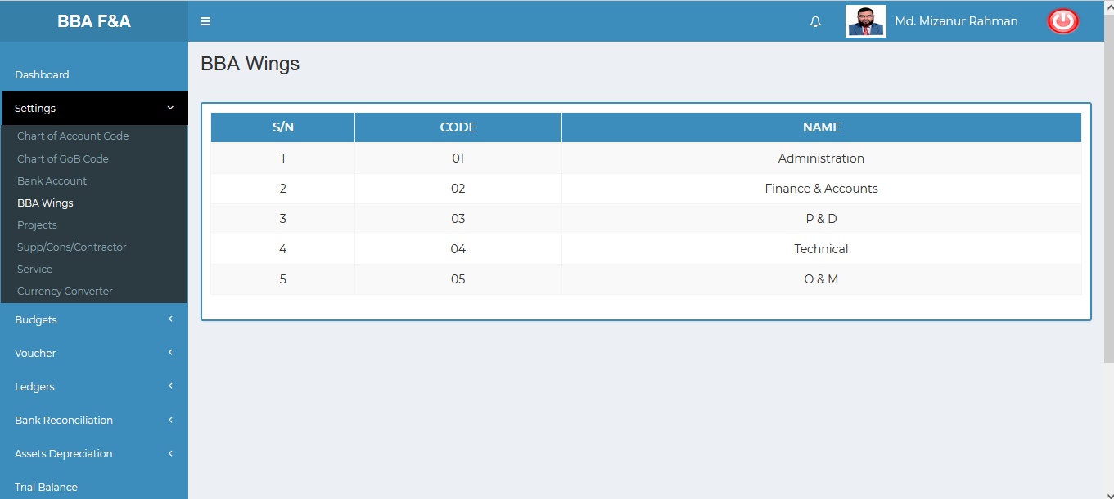

Figure 4.1.4.1: BBA wings (settings) bba wings view

### 4.1.5.1: Supp/Cons/Contractor (Settings) Add Data (Supplier,Consultant,Contractor) Input Field

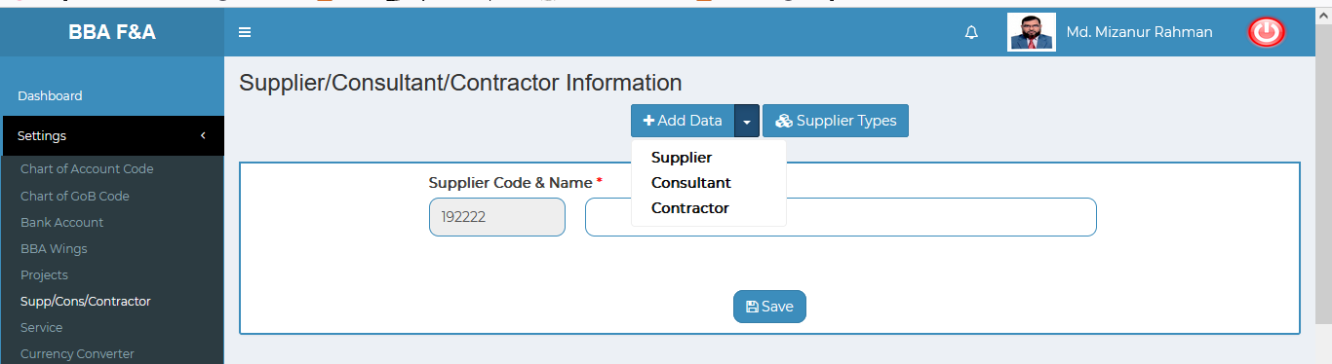

Figure 4.1.5.1.1: Supp/cons/contractor (settings)add data(supplier) input field

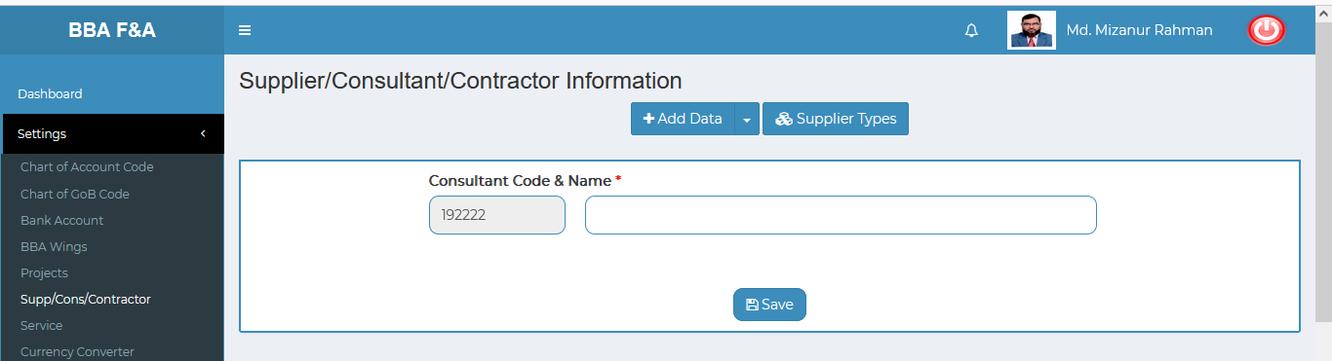

Figure 4.1.5.1.2: Supp/cons/contractor (settings)add data (consultant) input field

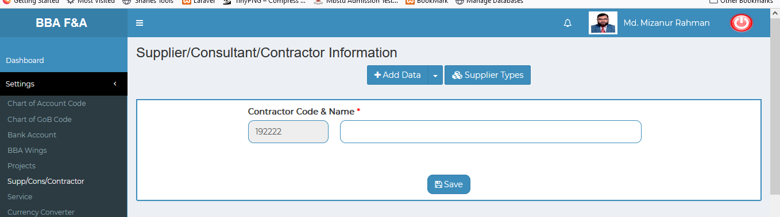

Figure 4.1.5.1.3: Supp/cons/contractor (settings)add data (contractor) input field

### 4.1.5.2: Supp/Cons/Contractor (Settings) View of details

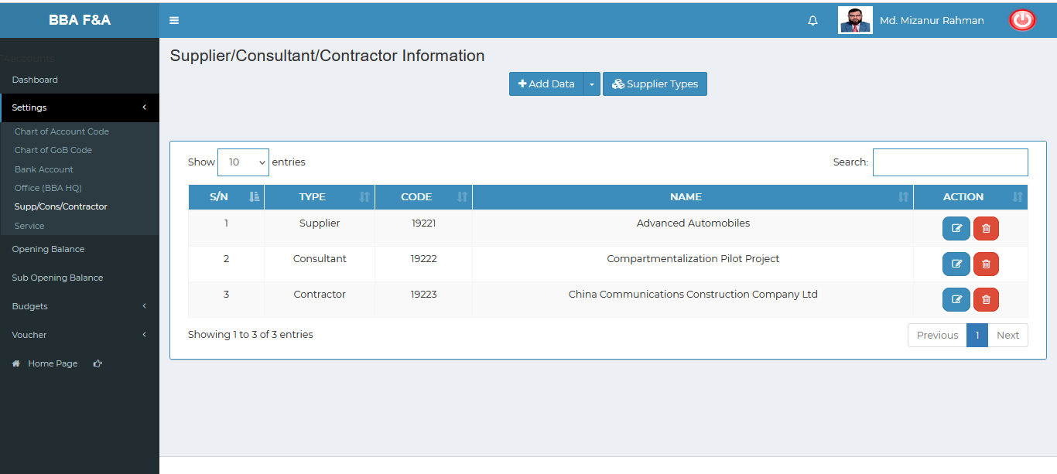

Figure 4.1.5.2: Supp/Cons/Contractor (settings) View of details

### 4.1.5.3: Supp/Cons/Contractor (Settings) Add Supplier type Input Field

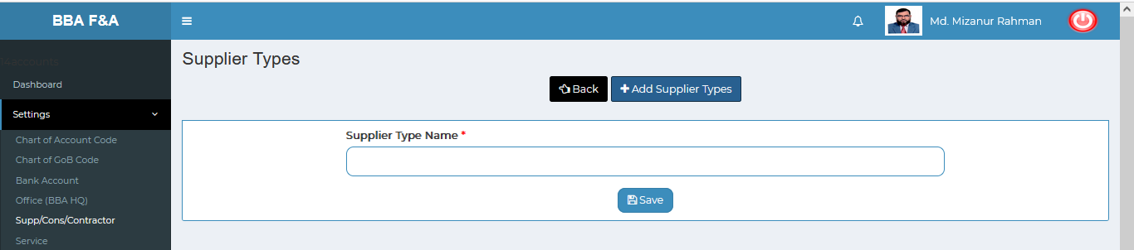

Figure 4.1.5.3: Supp/Cons/Contractor (settings) Add supplier type input field

### 4.1.5.4: Supp/Cons/Contractor (Settings) View Details of Add Supplier type

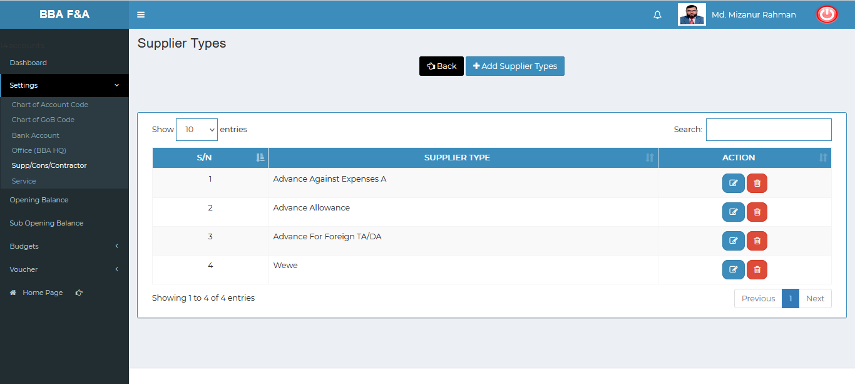 Figure 4.1.5.4: Supp/Cons/Contractor (settings) view details of add supplier type

### 4.1.5.4.1: Supp/Cons/Contractor (Settings) Add Supplier type Edit

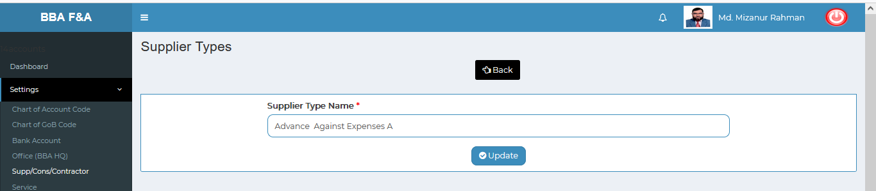

Figure 4.1.5.4.1: Supp/Cons/Contractor (settings) Add supplier type edit

### 4.1.5.4.2: Supp/Cons/Contractor (Settings) Add Supplier type Delete

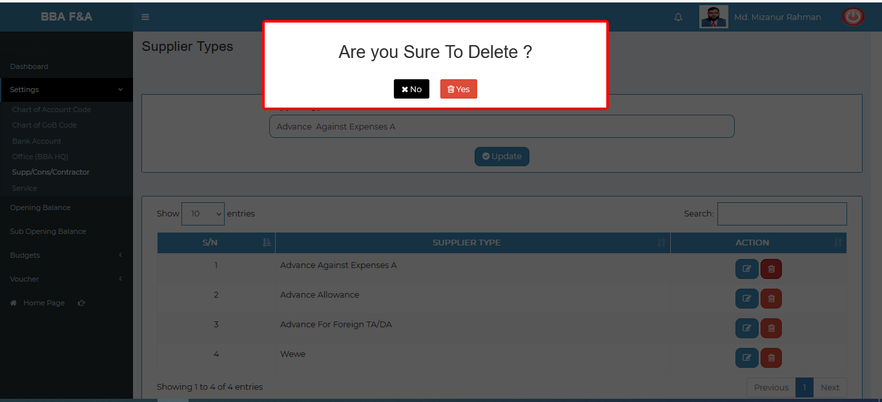

Figure 4.1.5.4.2: Supp/Cons/Contractor (settings) Add supplier type delete

### 4.1.5.5: Supp/Cons/Contractor (Settings) Edit Input Field

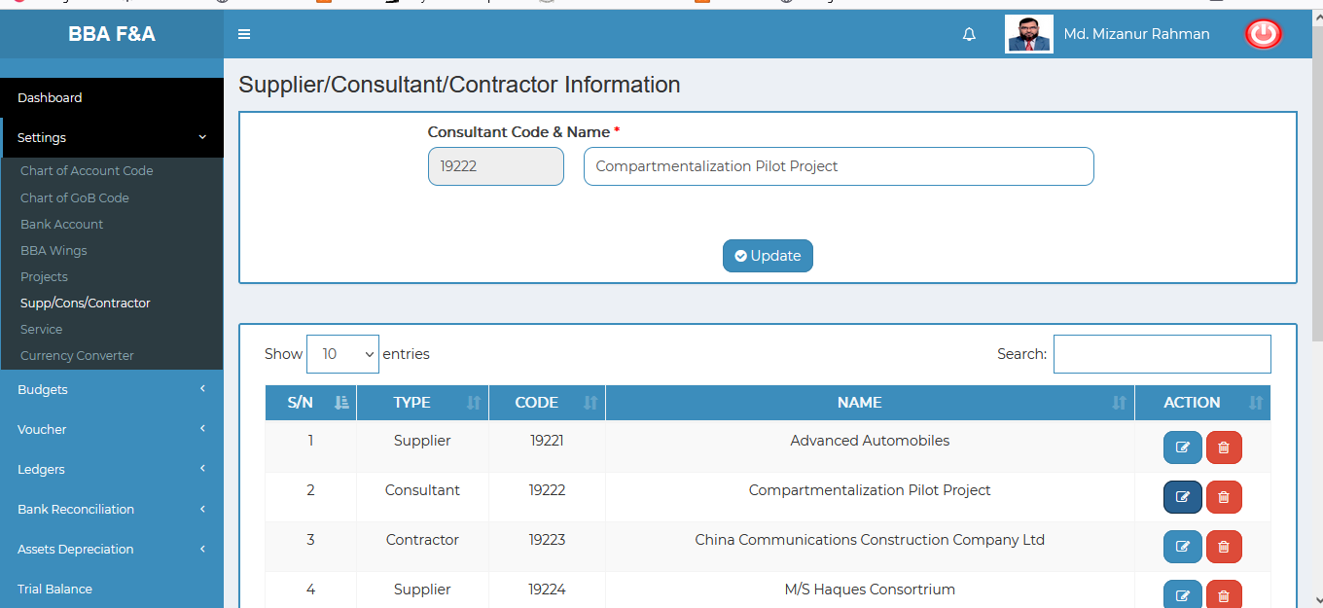

Figure 4.1.5.5: Supp/cons/contractor (settings) Update input field

### 4.1.5.6: Supp/Cons/Contractor (Settings) Delete

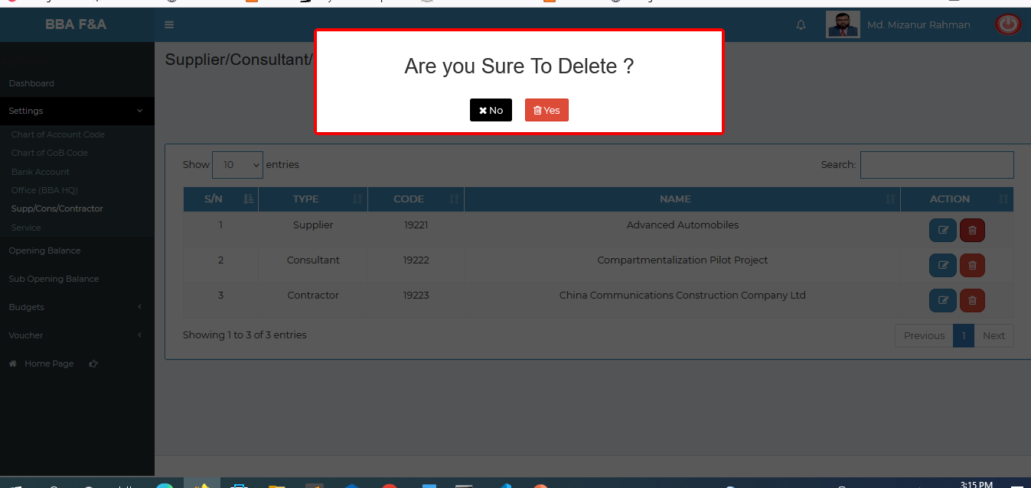

Figure 4.1.5.6: Supp/Cons/Contractor (settings) Delete

### 4.1.5.7: Supp/Cons/Contractor (Settings) Search

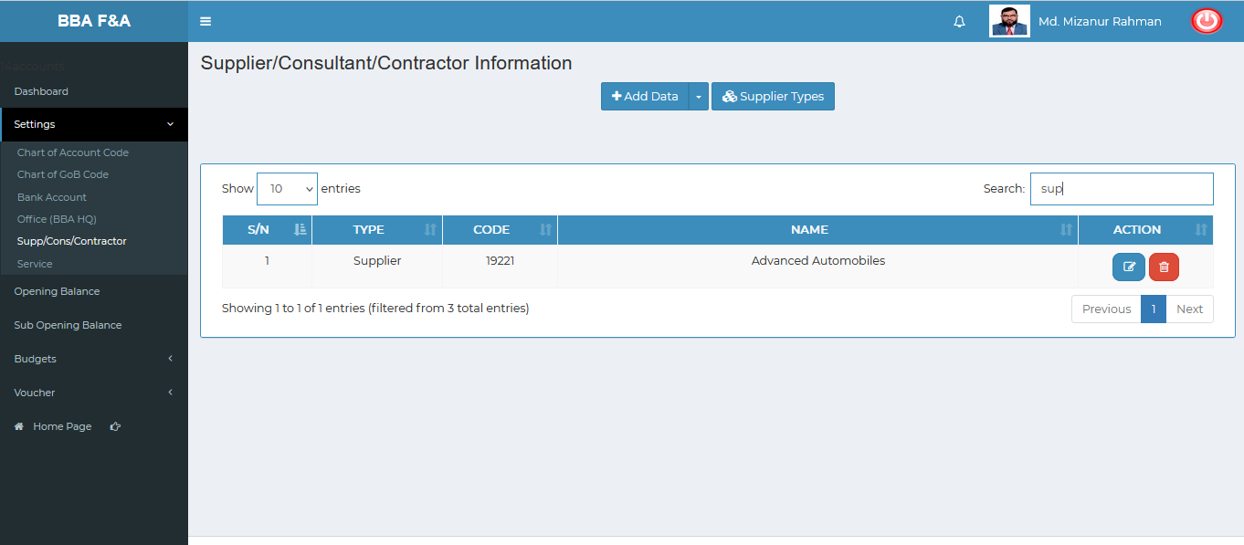

Figure 4.1.5.7: Supp/Cons/Contractor (settings) search

### 4.1.6.1: Service (Settings) Add New Service

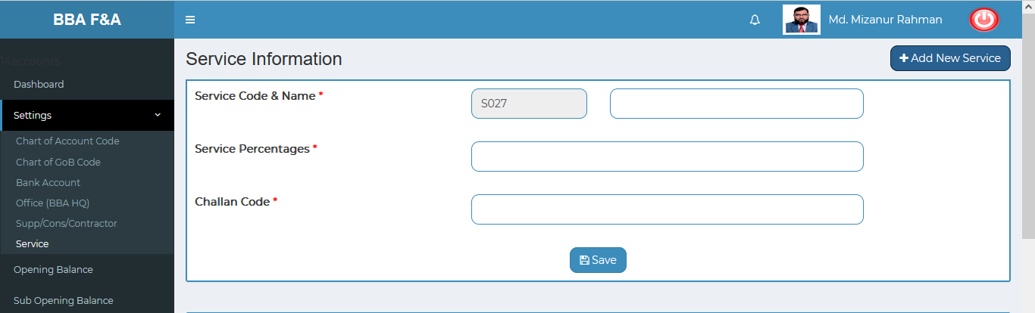

Figure 4.1.6.1: Service (settings)add new service input field

### 4.1.6.2: Service (Settings) View of service list details

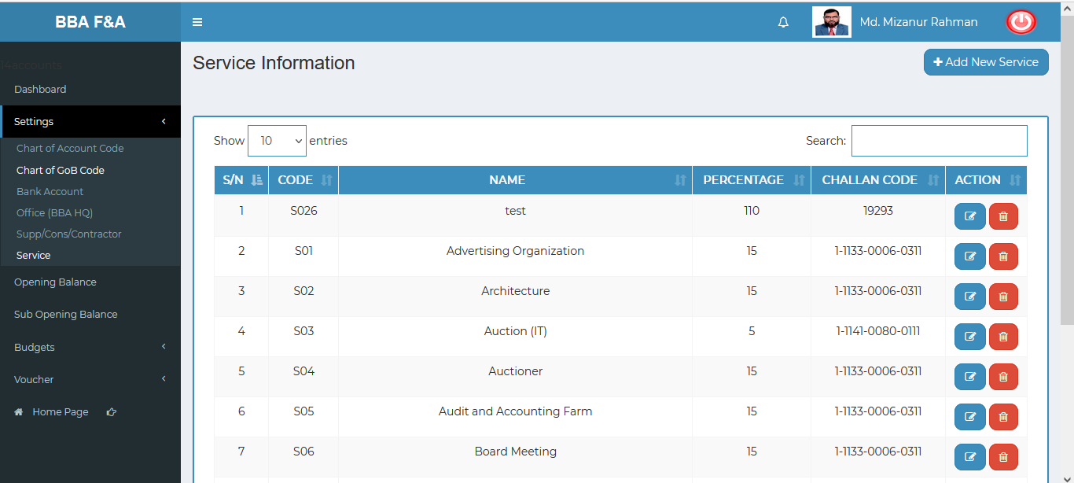

Figure 4.1.6.2: Service (settings) View of service list details

### 4.1.6.3: Service (Settings) Edit Input Field

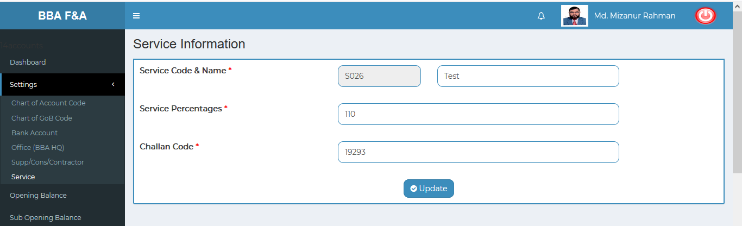

Figure 4.1.6.3: Service (settings) Update input field

### 4.1.6.4: Service (Settings) Delete

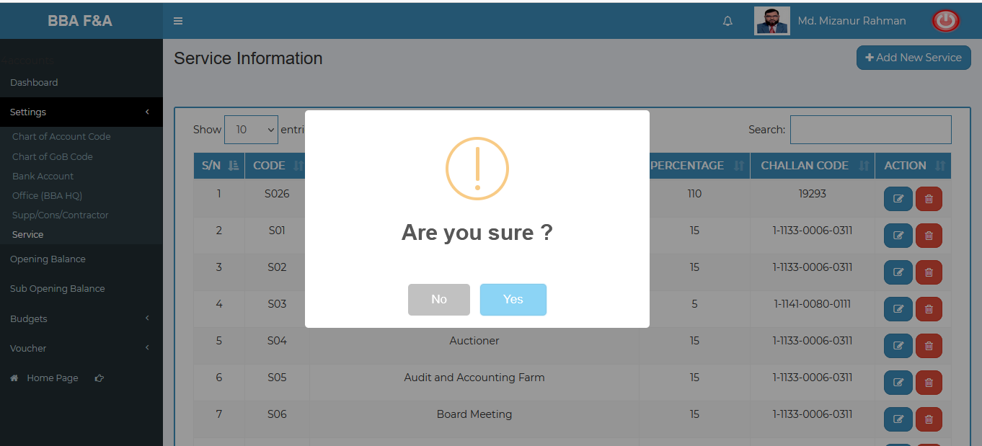

Figure 4.1.6.4: Service (settings) delete

### 4.1.6.5: Service (Settings) Search

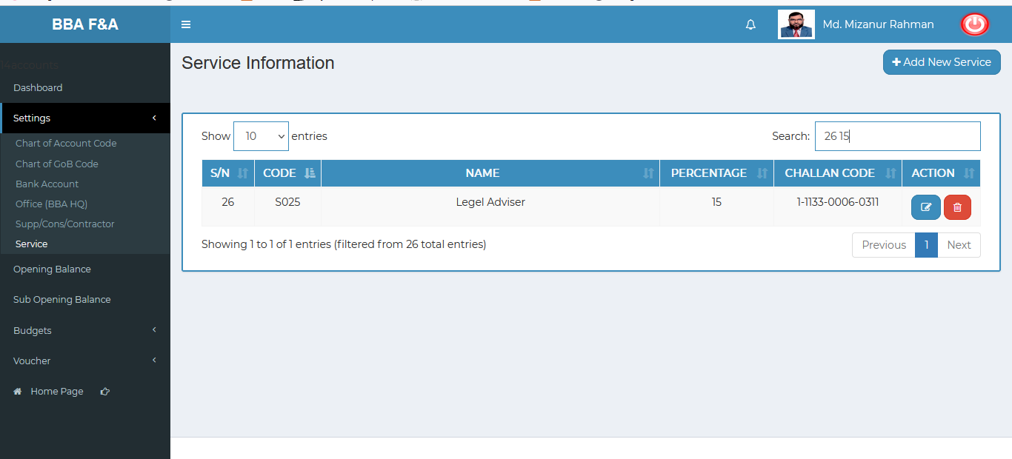

Figure 4.1.6.5: service (settings) search

### 4.1.7.1: Projects (Settings) Add Project input field

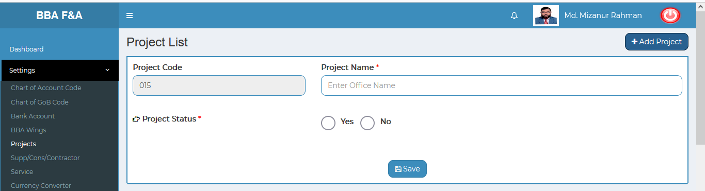

Figure 4.1.7.1: projects(settings) add project input field

### 4.1.7.2: Projects (Settings) View details of project list

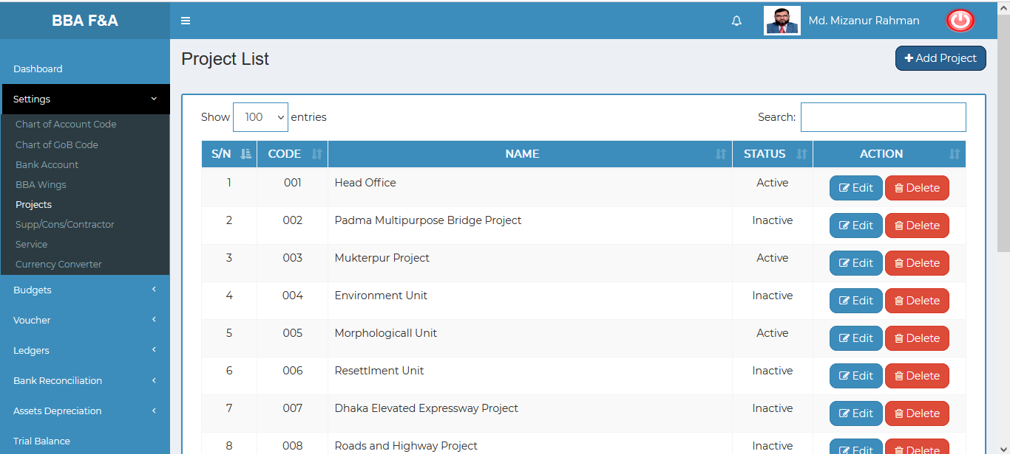

Figure 4.1.7.1: projects(settings) view details of project list

### 4.1.7.3: Projects (Settings) Edit

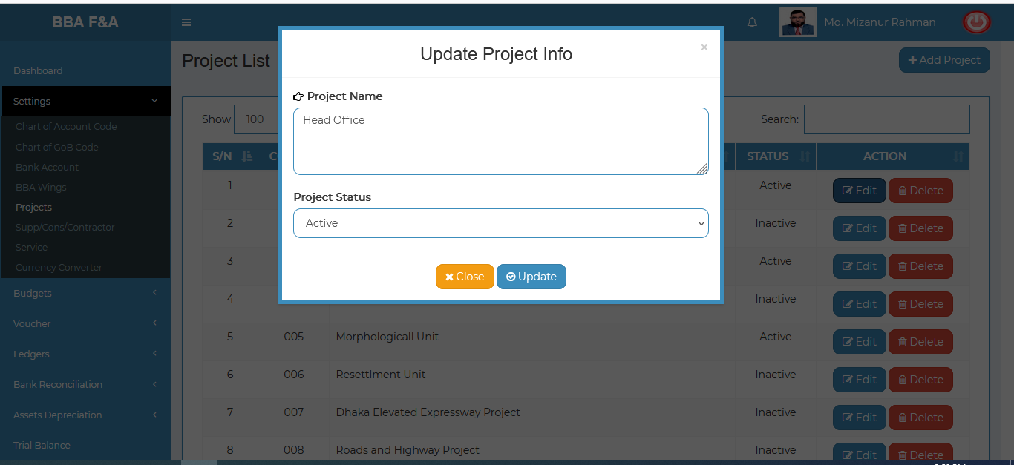

Figure 4.1.7.3: projects(settings) update input field

### 4.1.7.4: Projects (Settings) Delete

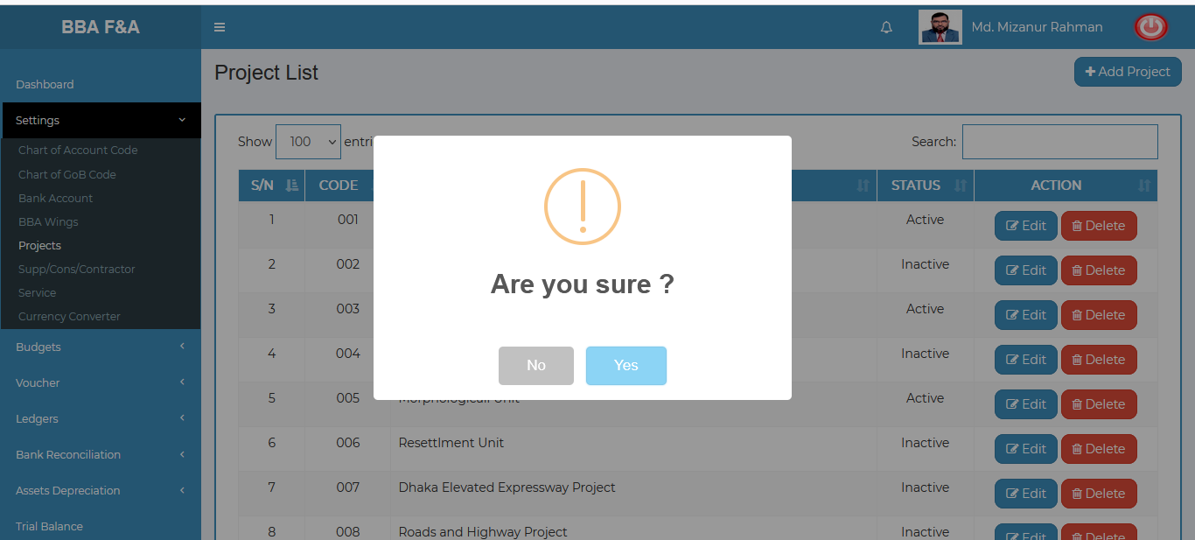

Figure 4.1.7.4: projects(settings) data delete pop-up modal

### 4.1.7.5: Projects (Settings) Search

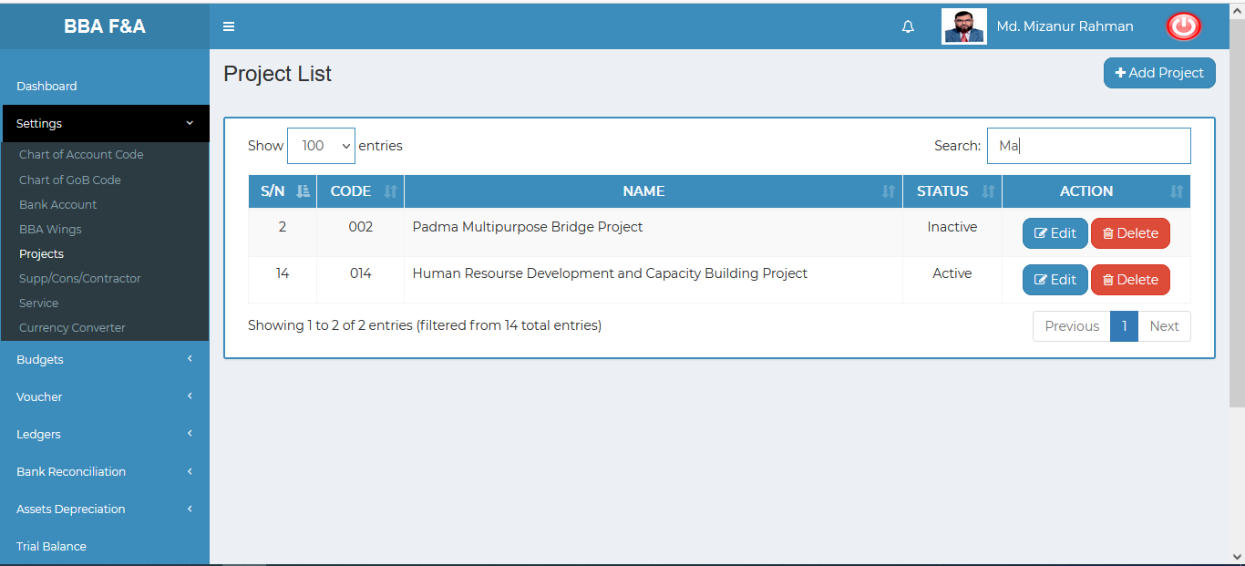

Figure 4.1.7.5: projects(settings) search

### 4.1.8.1: Currency Converter (Settings) Currency Converter input field

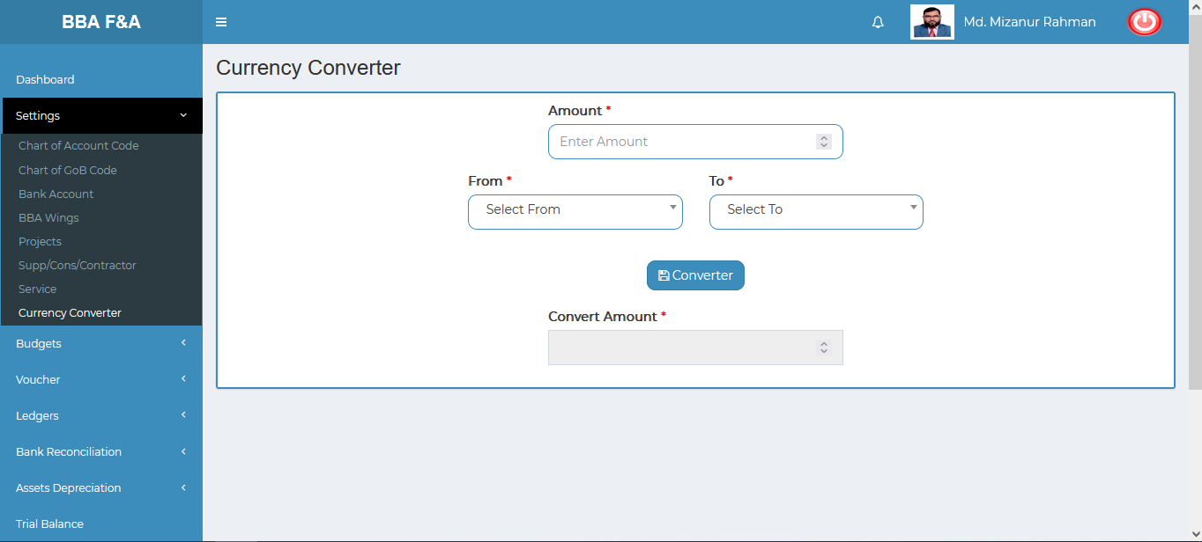

Figure 4.1.8.1: currency converter input field

## 4.2: Budgets Menu Overview

**Overview of Budgets**

Click on the Budgets menu after that there will appear seven(05) sub-menu & they are **Budget Entry , Budget Manage ,Expenses Entry, Manage Expenses , Report .**

### 4.2.1.1: Budget Entry (Budgets) Budget Entry input field

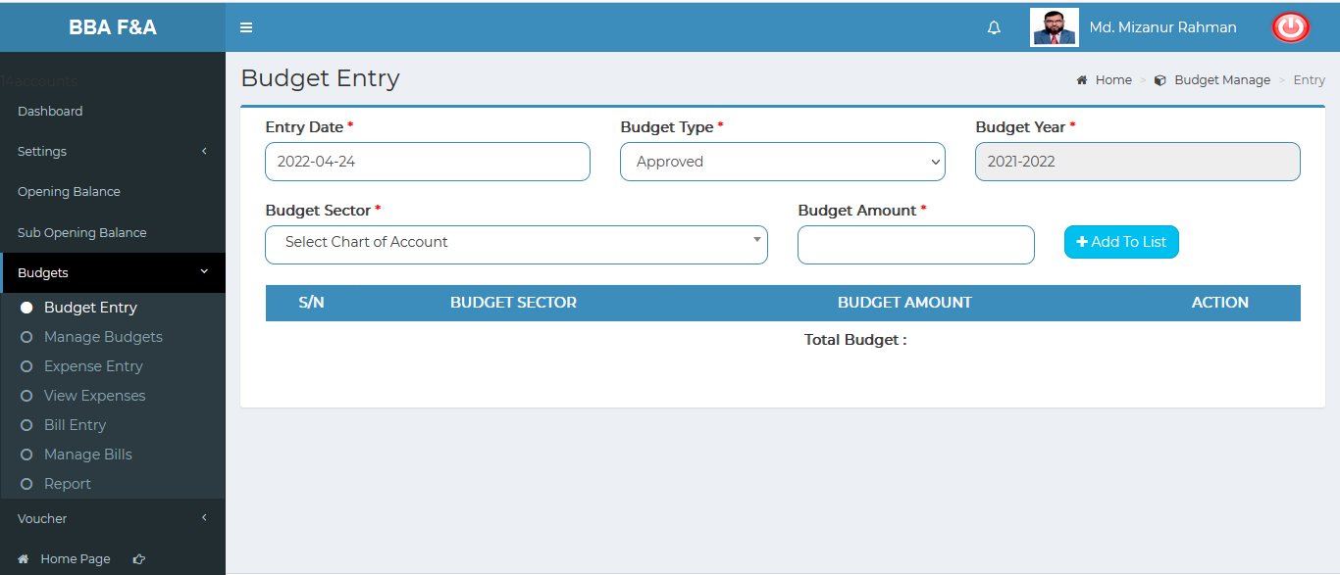

Figure 4.2.1.1: Budget entry(budgets) budget entry input field

### 4.2.1.2: Budget Entry (Budgets) View of Budget Entry Data

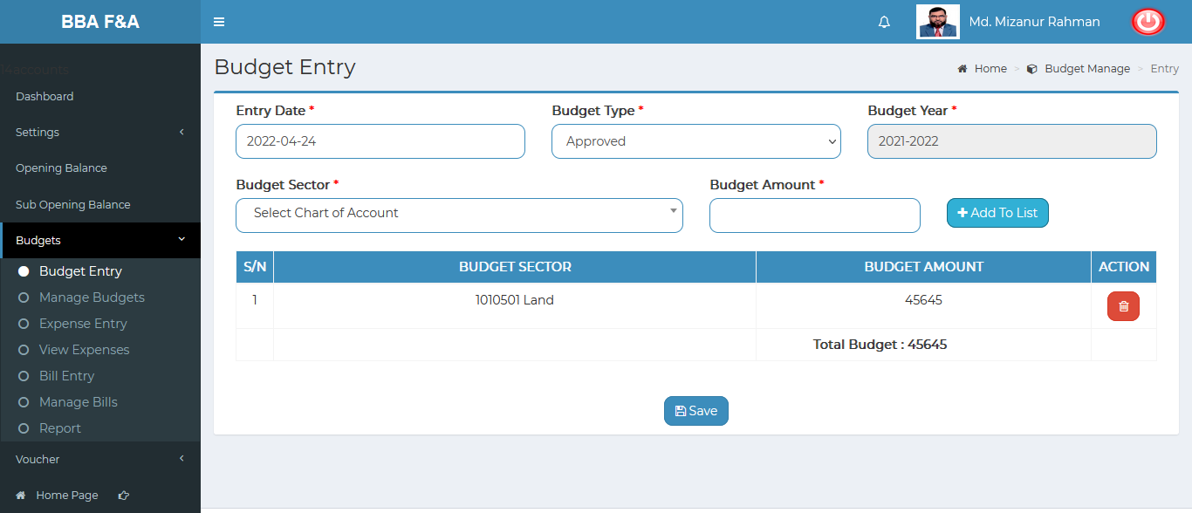

Figure 4.2.1.2: Budget entry(budgets) view of budget entry data

### 4.2.2.1: Manage Budget (Budgets) View all budget info (Year Wage)

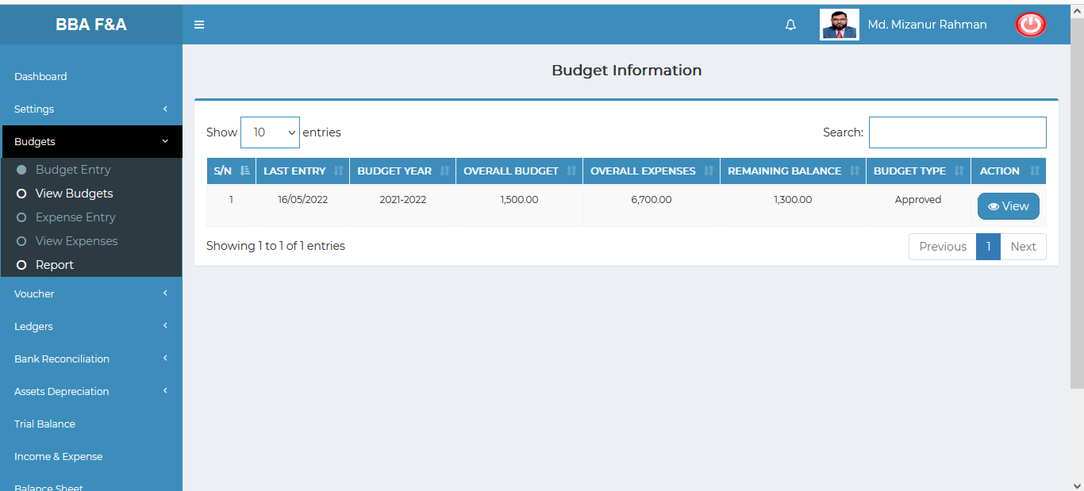

Figure 4.2.2.1: manage budget (budgets) view of all budget info (year wage)

### 4.2.2.2: Manage Budget (Budgets) View of single budget info

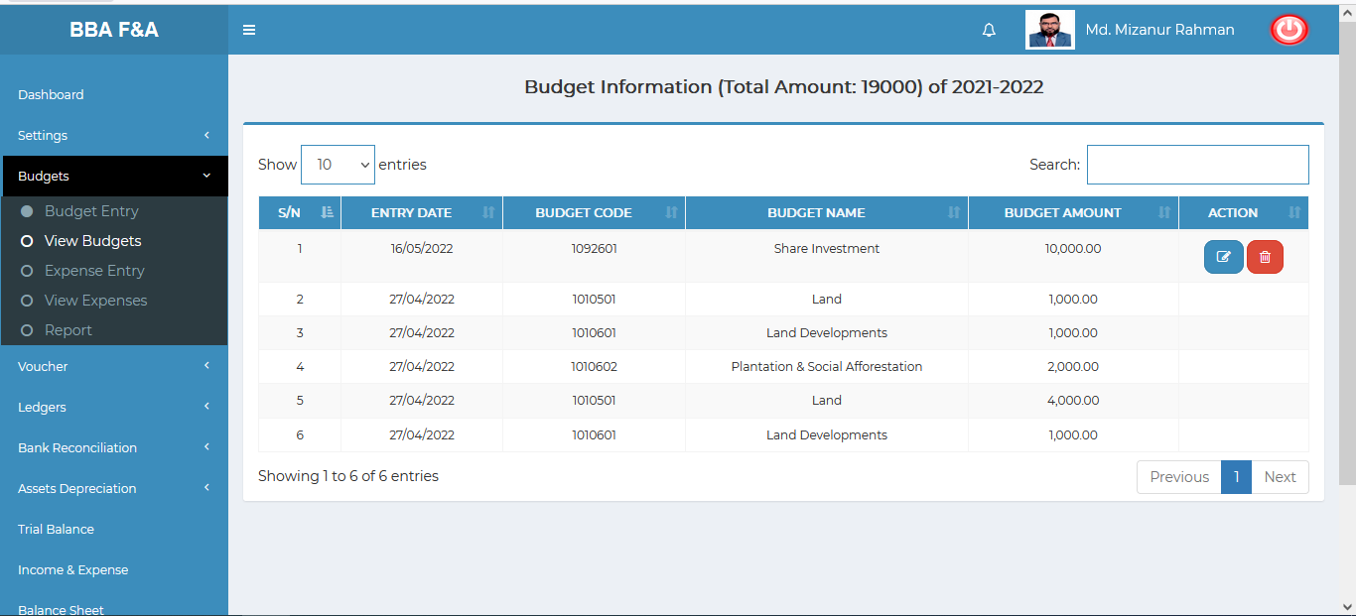

Figure 4.2.2.2: manage budget (budgets) view of single budget info

### 4.2.2.2.1: Manage Budget (Budgets) View of single budget info (Edit)

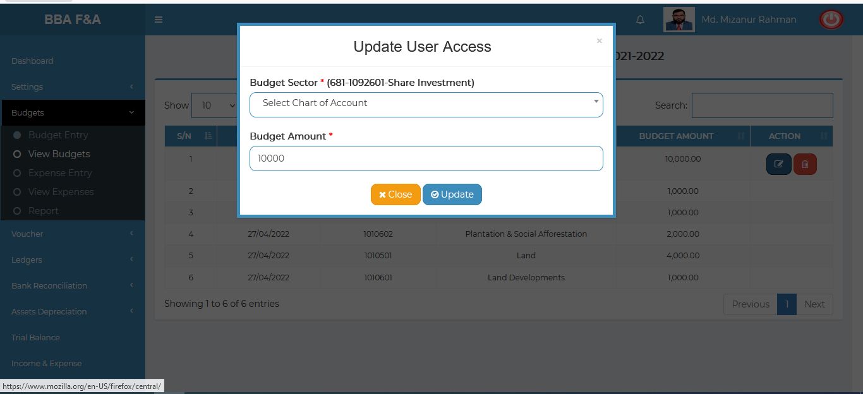

Figure 4.2.2.2.1: manage (budgets) view of single budget info (edit)

### 4.2.2.2.2: Manage Budget (Budgets) View of single budget info (Delete)

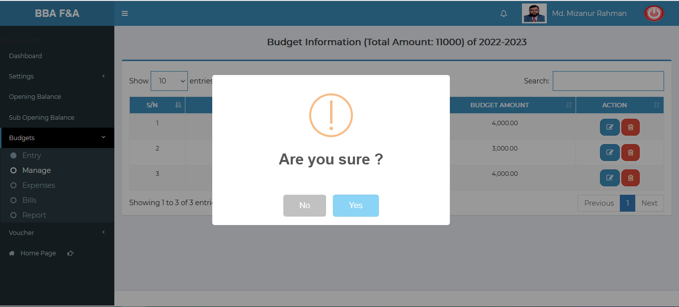

Figure 4.2.2.2.2: manage budget (budgets) view of single budget info (delete)

### 4.2.2.3: Manage Budget (Budgets) Search

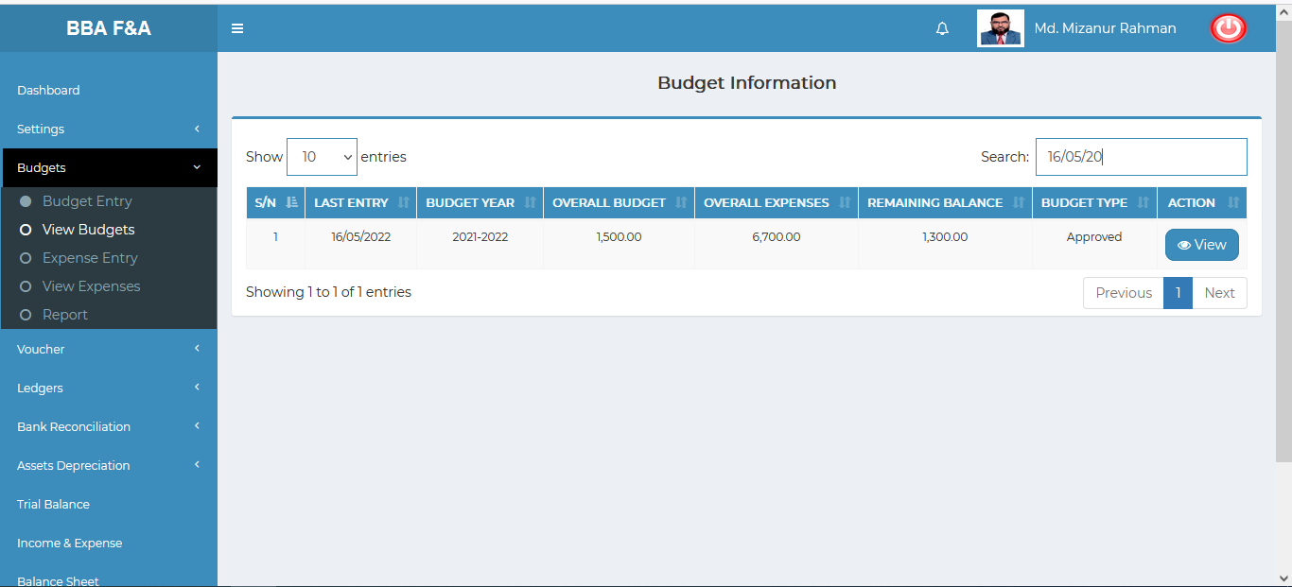

Figure 4.2.2.2.2: manage budget (budgets) search

### 4.2.3.1: Expense Entry (Budgets) Expense Entry input field

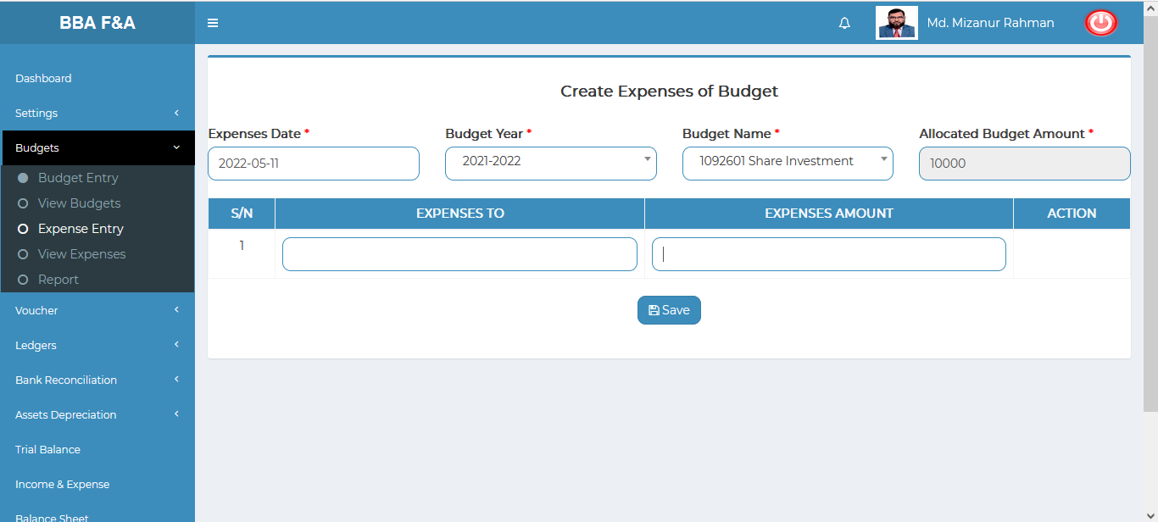

Figure 4.2.3.1: Expenses entry input field

### 4.2.4.1: Manage Expenses (Budgets) View details of budget expenses information

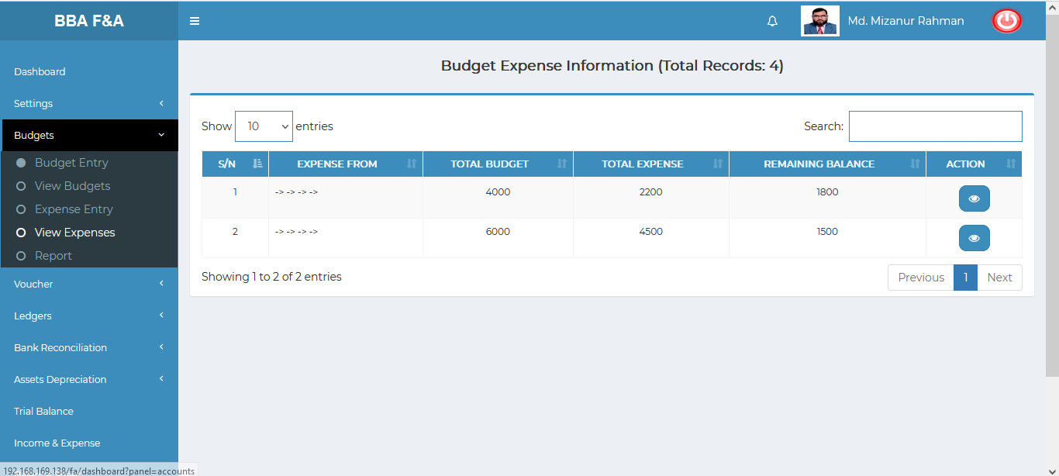

Figure 4.2.4.1: View details of budget expenses information

### 4.2.4.2.1: Manage Expenses (Budgets) Single budget expenses information

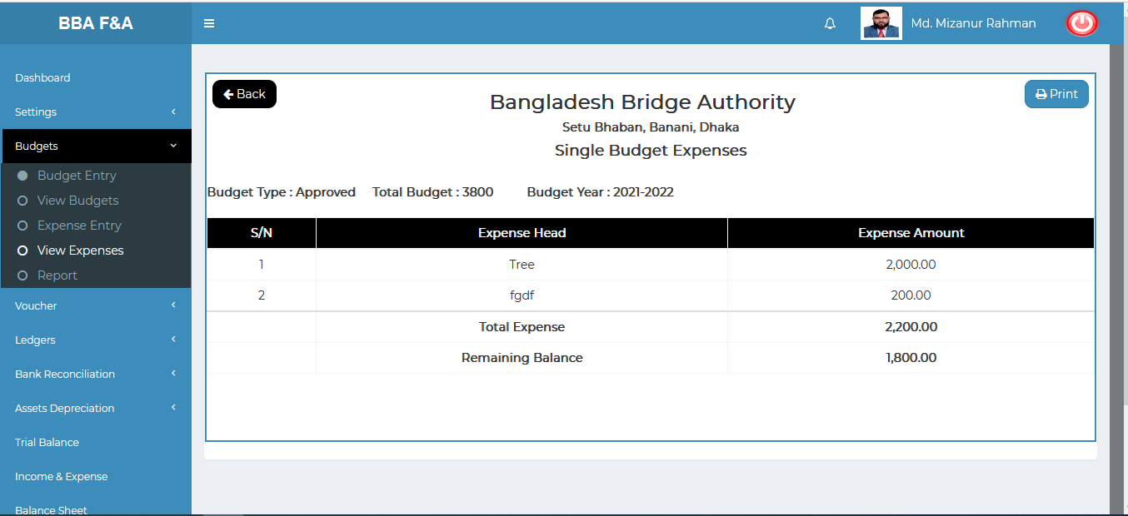

Figure 4.2.4.2.1: Single budget expenses information

### 4.2.4.2.2: Manage Expenses (Budgets) View details of budget expenses information(Print)

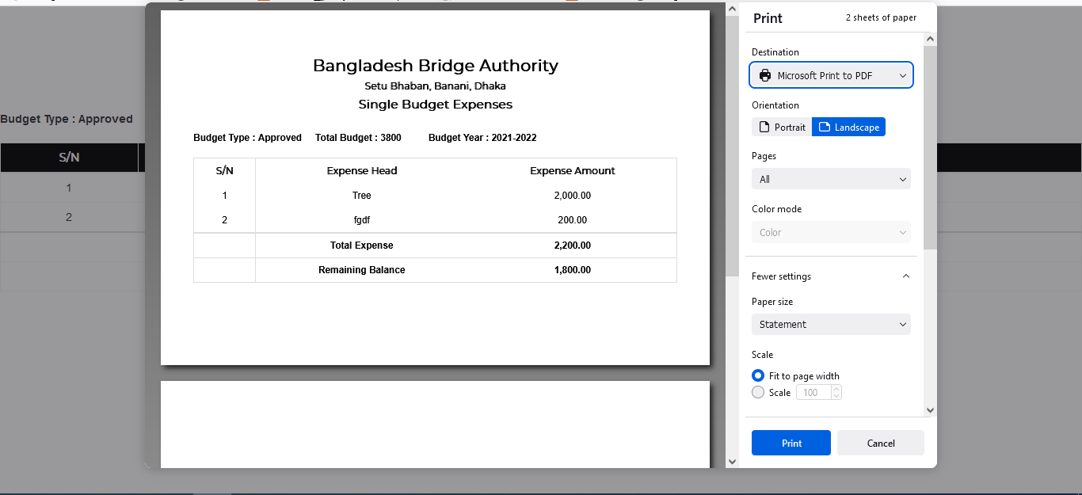

Figure 4.2.4.2.2: Single budget expenses information(print)

### 4.2.5.1: Report (Budgets) Search all allocated budget sector

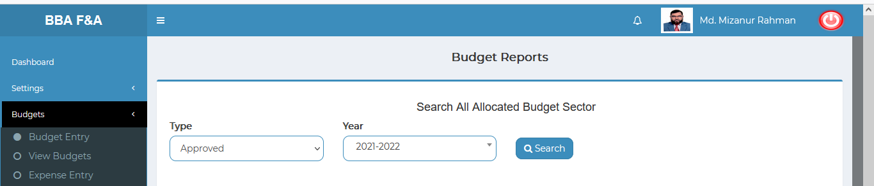

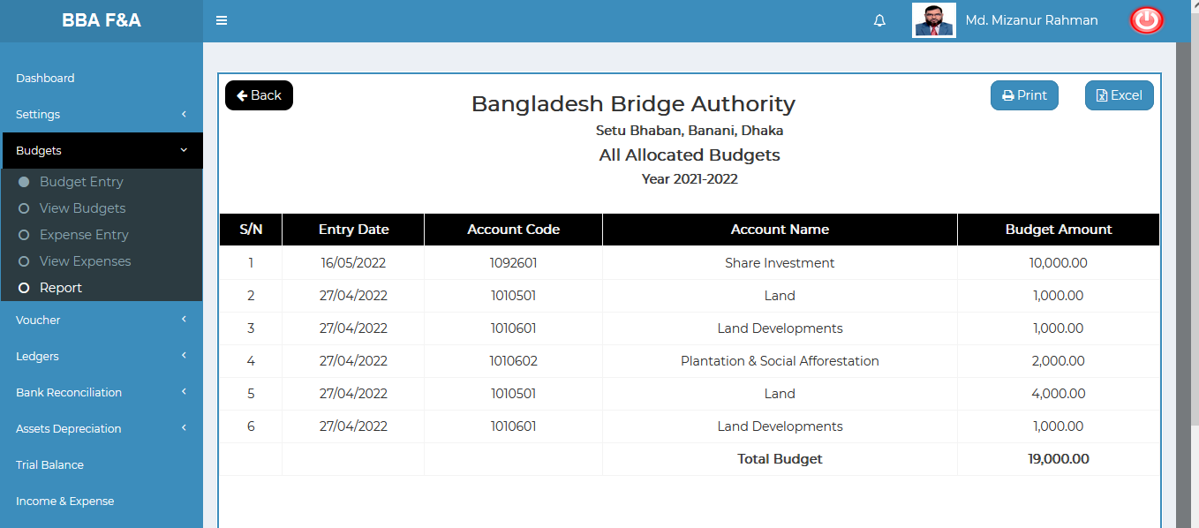

Figure 4.2.5.1: all allocated budget data(search) result

### 4.2.5.1.1: Report (Budgets) Search all allocated budget sector(Download excel file)

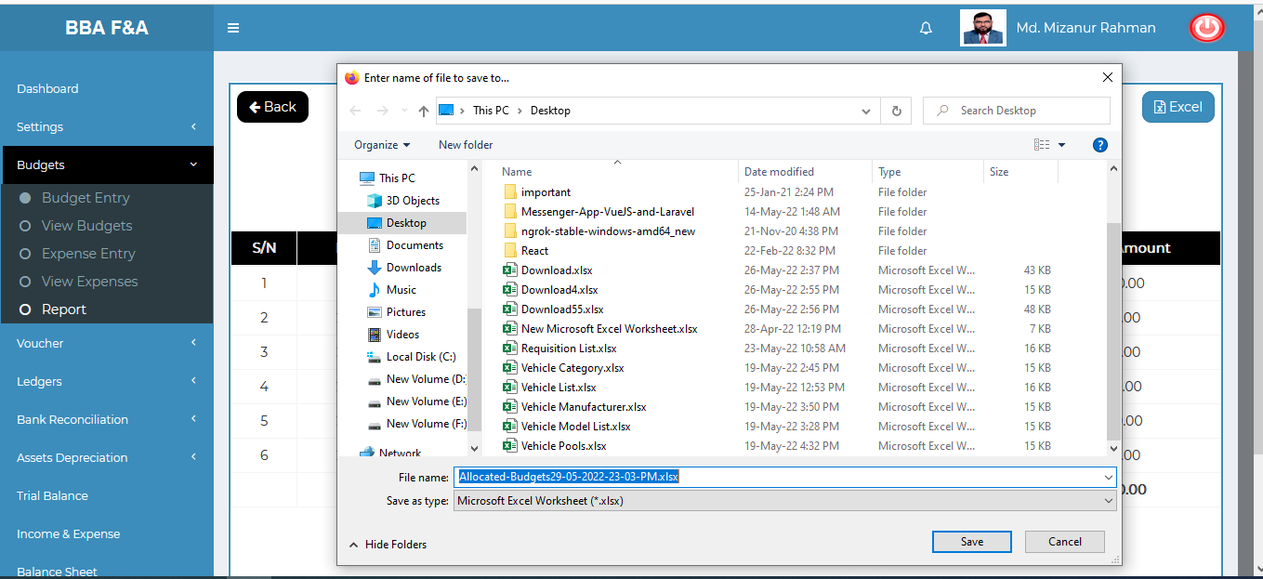

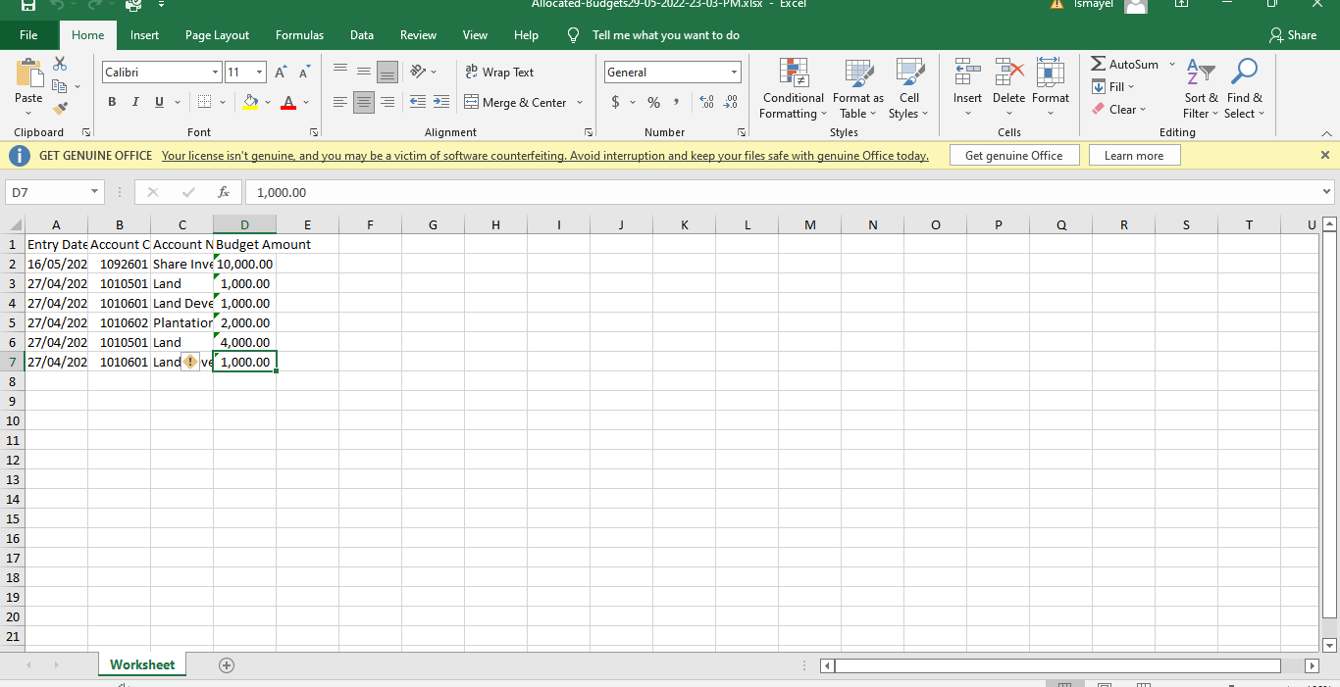

Figure 4.2.5.1.1: all allocated budget download & excel file data

### 4.2.5.2: Report (Budgets) Search all expenses (from allocated budget sector)

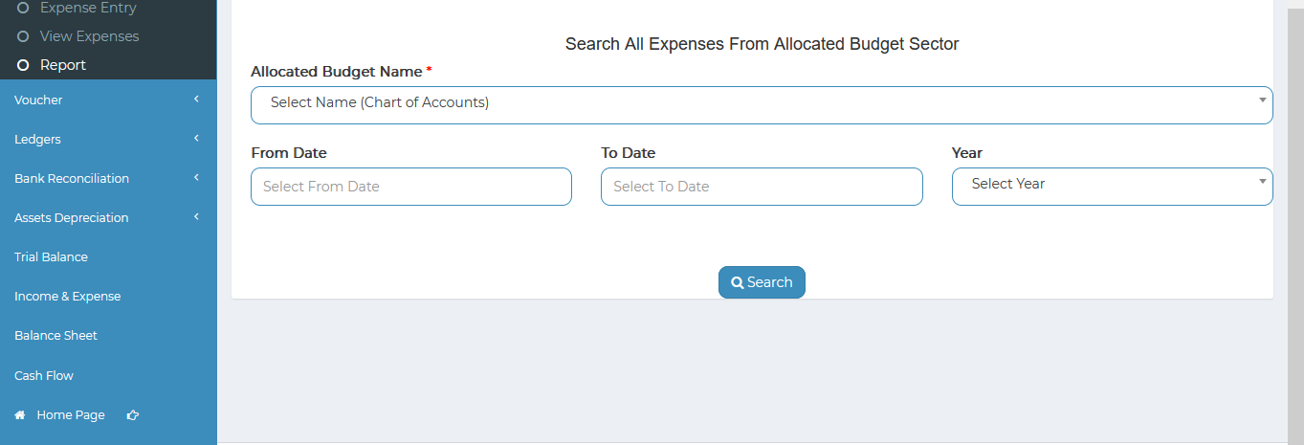

Figure 4.2.5.2: all expenses(search) input field

## 4.3: Voucher Menu Overview

**Overview of Voucher**

Click on the Voucher menu after that there will appear three (03) sub-menu & they are **Entry , Manage,Old Records.**

### 4.3.1.1: Entry (Voucher) Voucher entry form

Figure 4.3.1.1: Manage (Voucher) all voucher information list

### 4.3.1.2: Manage (Voucher) View Single voucher Details

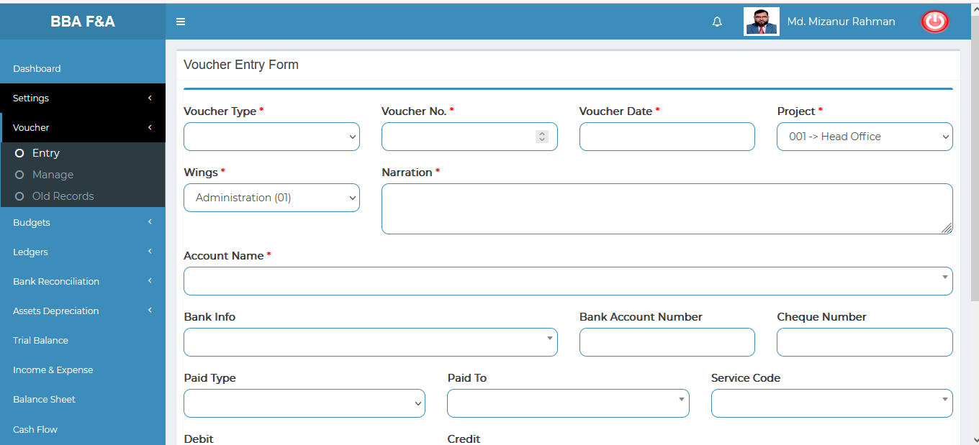

Figure 4.3.1.2: voucher entry input from

### 4.3.2.1: Manage (Voucher) View Voucher Information

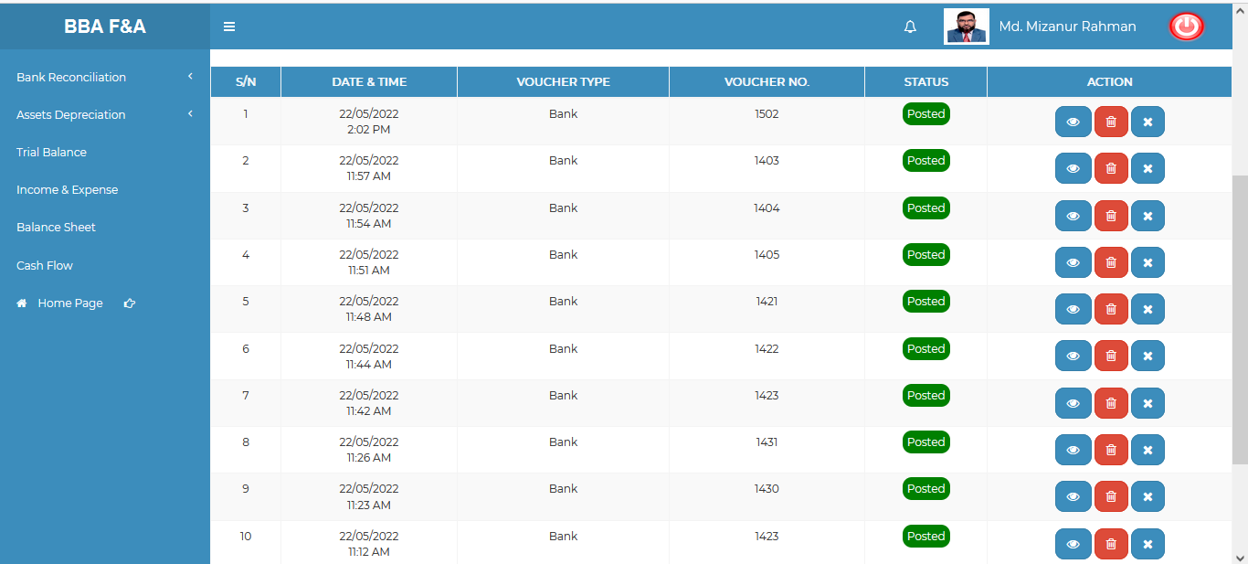

Figure 4.3.2.1: voucher information list

### 4.3.2.2: Manage (Voucher) Single voucher details information

**View:** single voucher details list

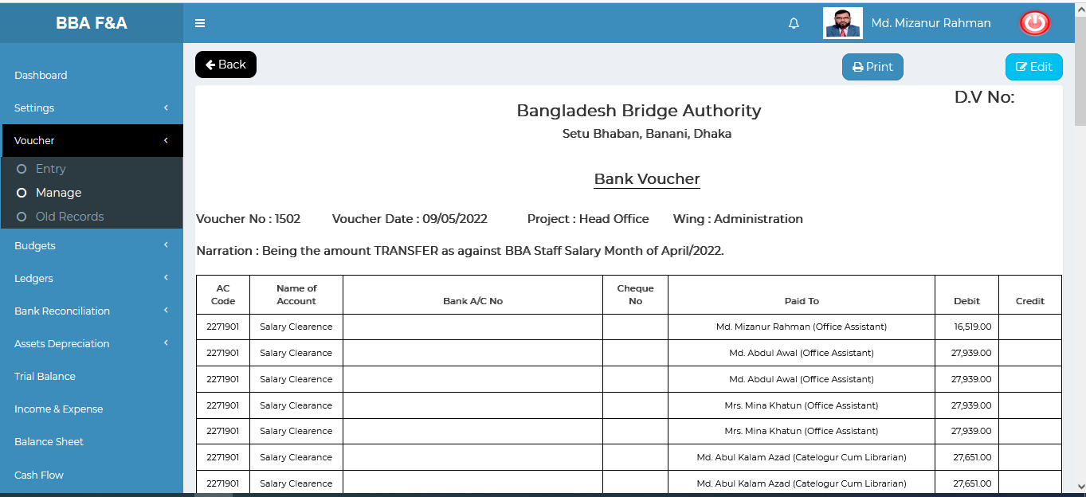

Figure: Single voucher details list

**Edit**:Click on the edit button it will redirect to edit page.User can update the voucher information as user required.

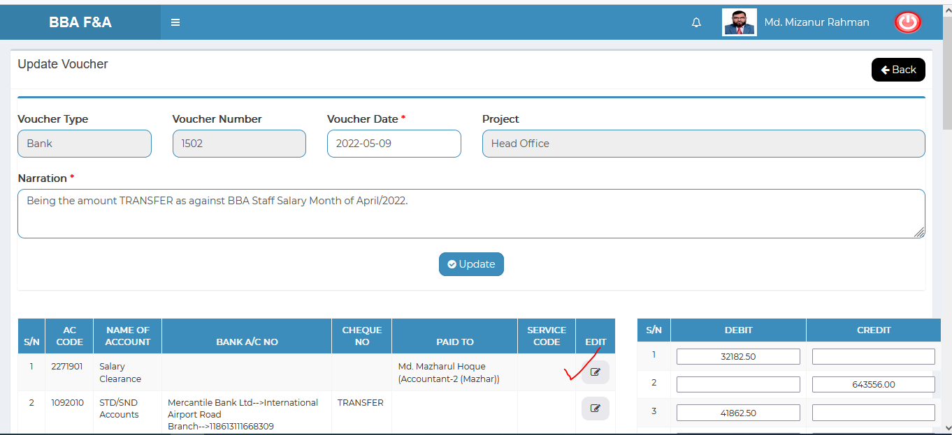

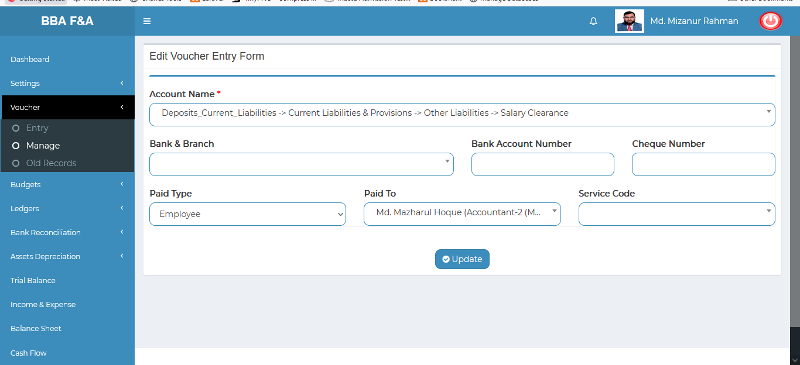

Figure: Single Voucher edit form

**Print**: Click on the print button after that looks like printing functionality will appear as we see in the below picture.

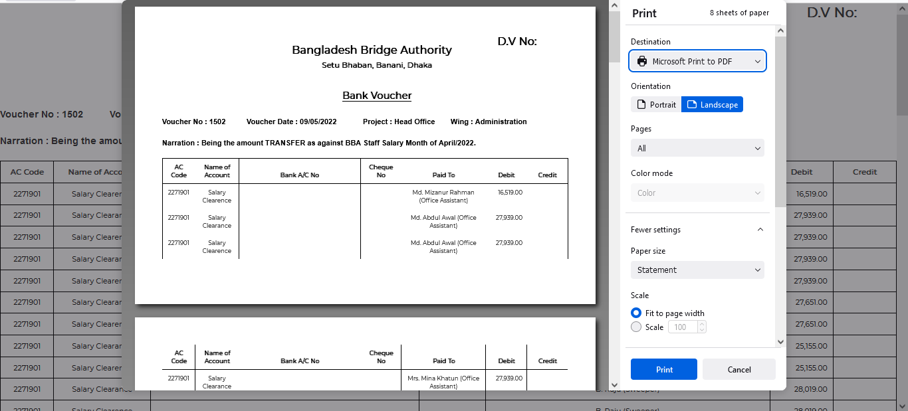

Figure: Single voucher printing functionality.

### 4.3.2.3: Manage (Voucher) delete

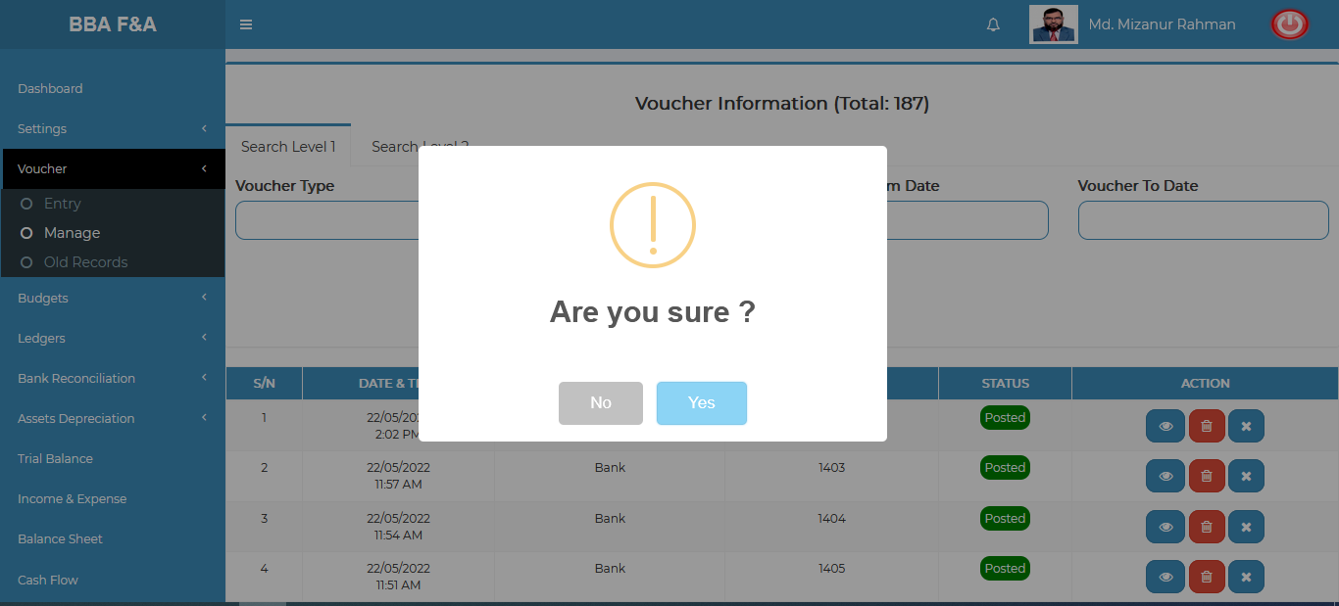

Figure 4.3.2.3: voucher delete

### 4.3.2.4: Manage (Voucher) Unpost

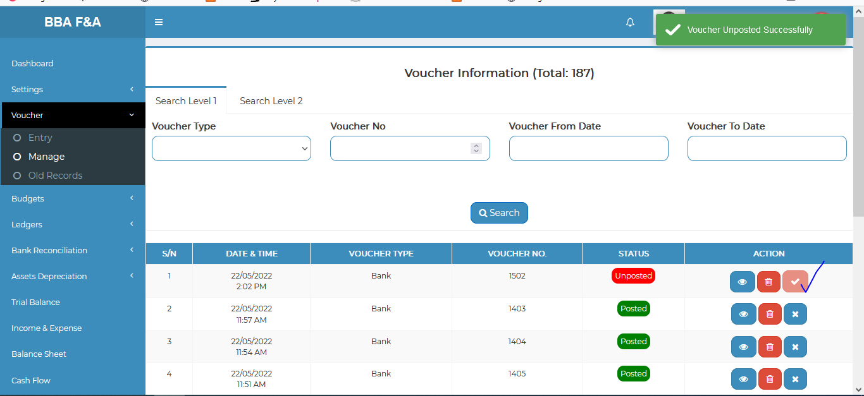

Figure 4.3.2.4: Voucher unpost

### 4.3.2.5: Manage (Voucher) Voucher search

**Search Level-1**

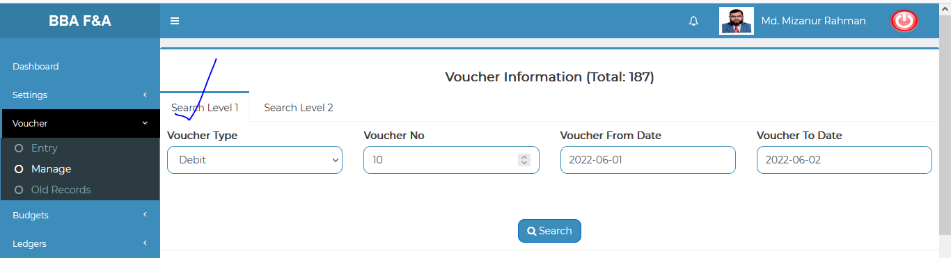

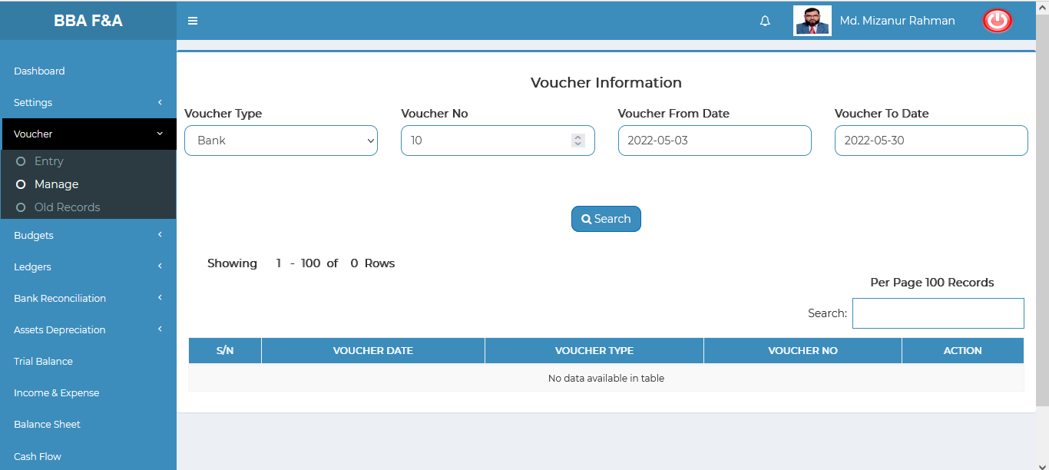

Figure: Voucher search level-1 input field & result

**Search Level-2**

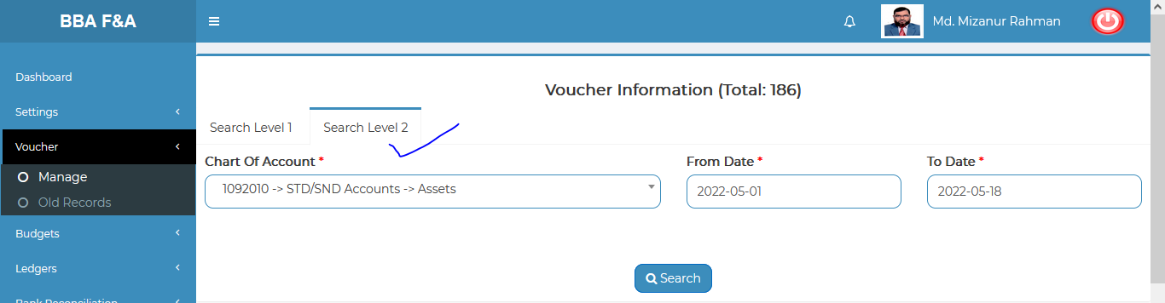

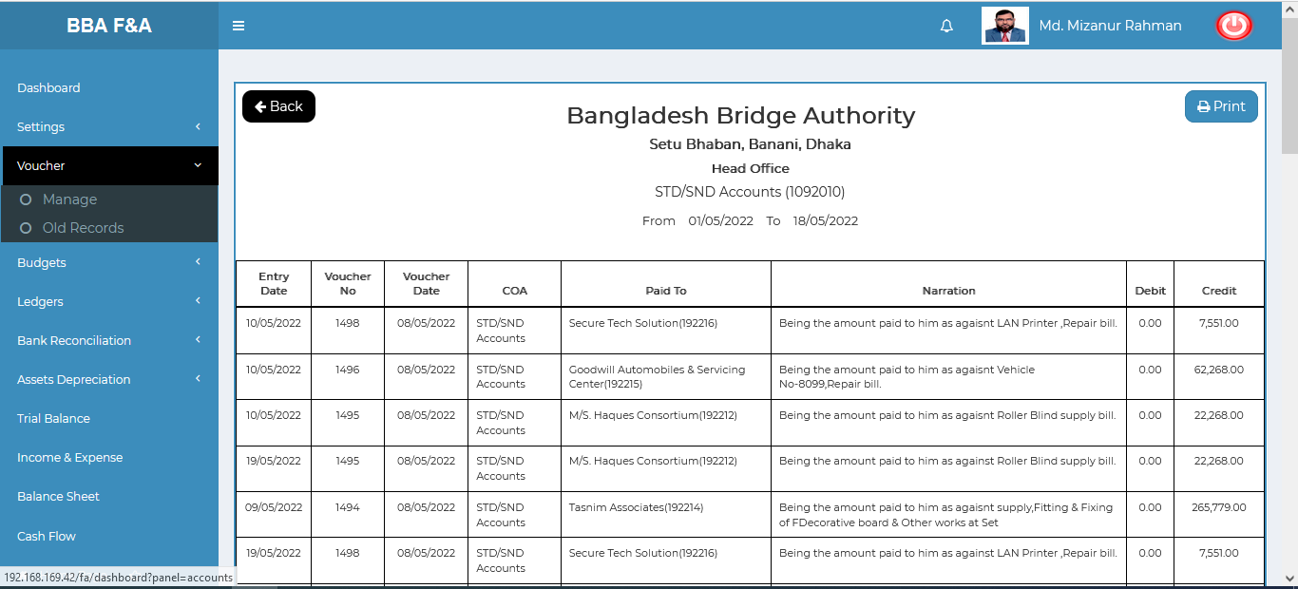

Figure: Voucher search level-2 input field & result

### 4.3.3.1: Old Records (Voucher) Search old voucher input form

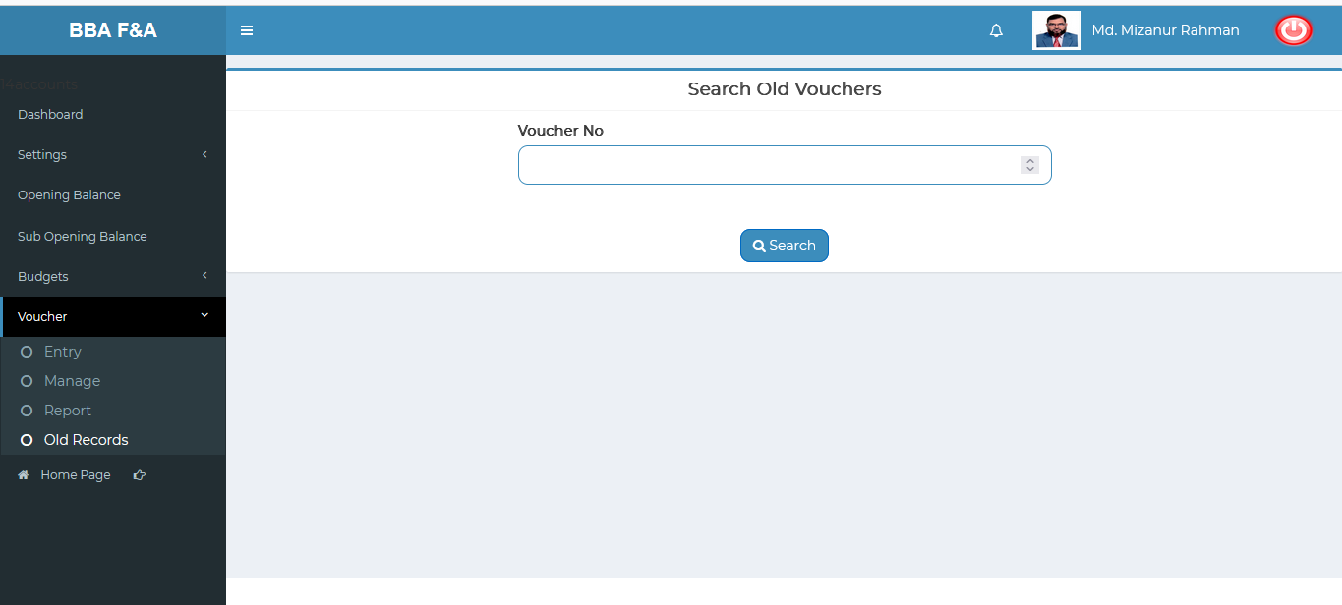

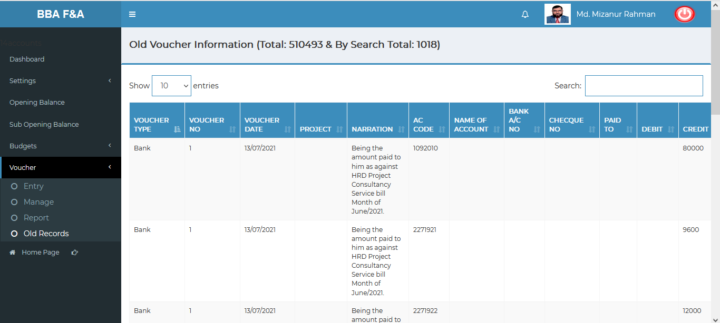

Figure 4.3.3.1: old record search input field & result

## 4.4: Ledgers Menu Overview

**Overview of Ledger**

Click on the Ledgers menu after that there will appear three (03) sub-menu & they are **General Ledger , Subsidiary Ledger ,Bank Ledger.**

### 4.4.1.1: General Ledger (Ledgers) Generate general ledger input form

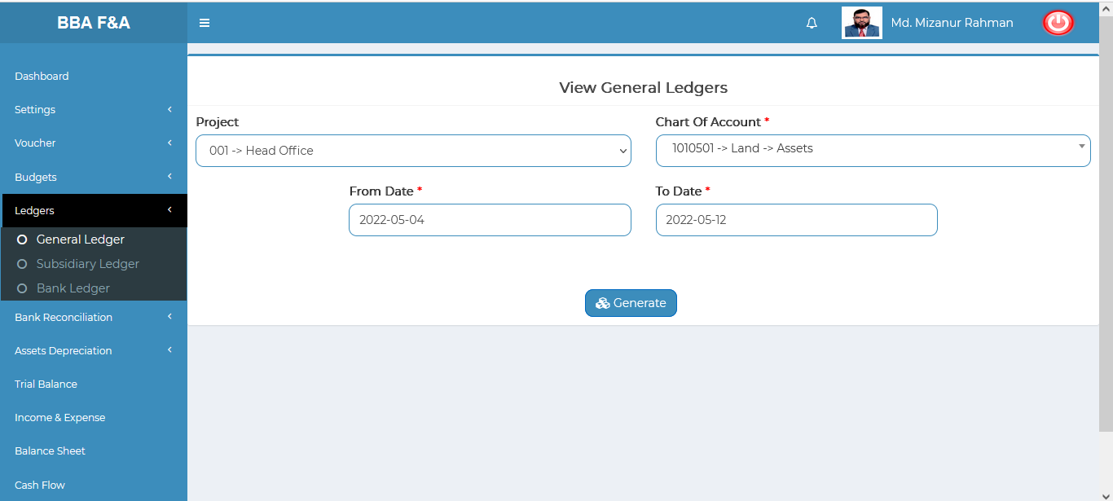

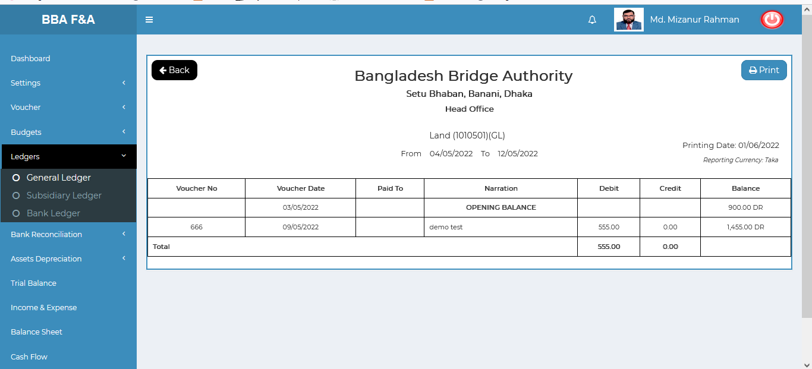

Figure 4.4.1.1: Generating general ledger input form & result

### 4.4.2.1: Subsidiary Ledger (Ledgers) Generate subsidiary ledger input form

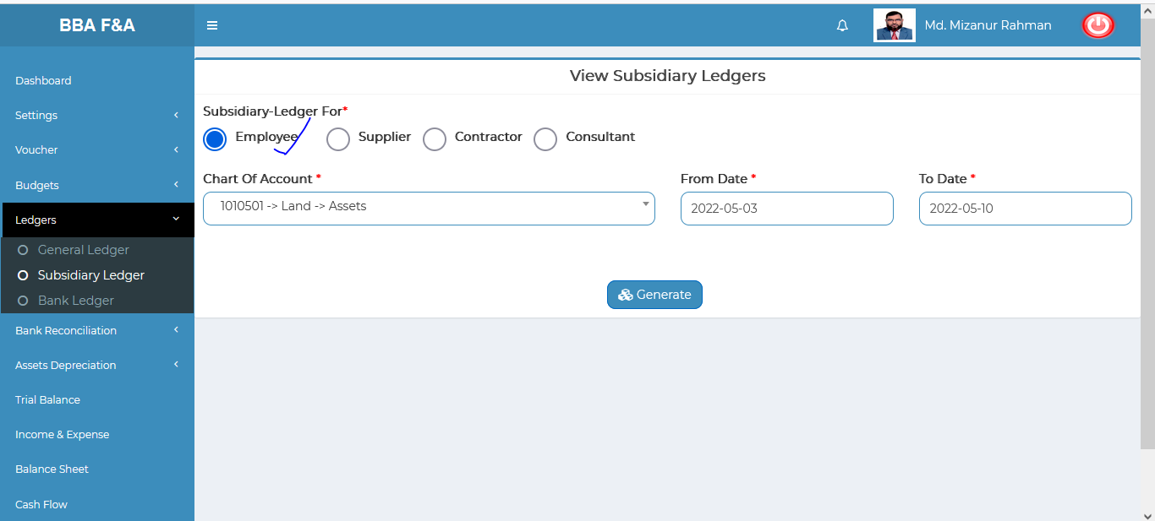

Figure 4.4.2.1: Generating subsidiary ledger input form

### 4.4.3.1: Bank Ledger (Ledgers) Generating Bank ledger input form

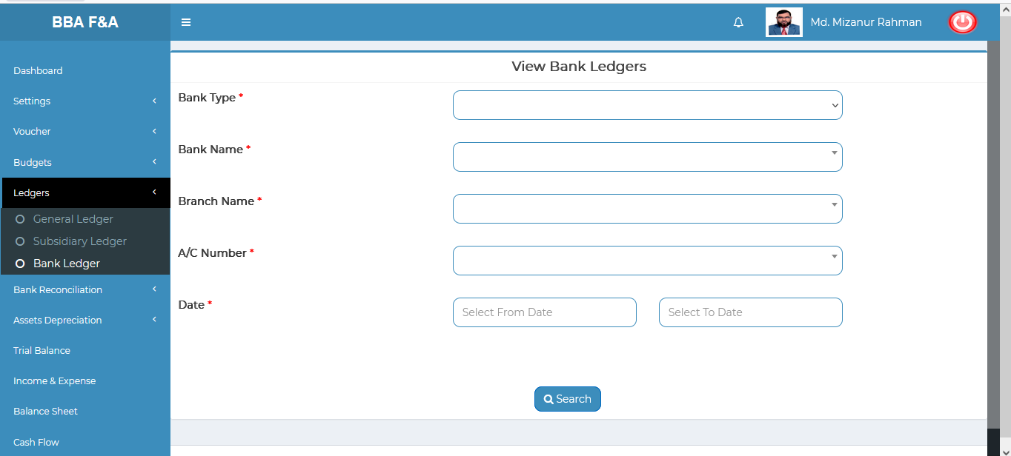

Figure 4.4.3.1: Generating bank ledger input form

## 4.5: Bank Reconciliation Menu Overview

**Overview of Ledger**

Click on the Bank Reconciliation menu after that there will appear three (03) sub-menu & they are **Upload Statement , View Statement ,Generate.**

4.5.1.1: Upload Statement (Bank Reconciliation) Upload bank statement input form

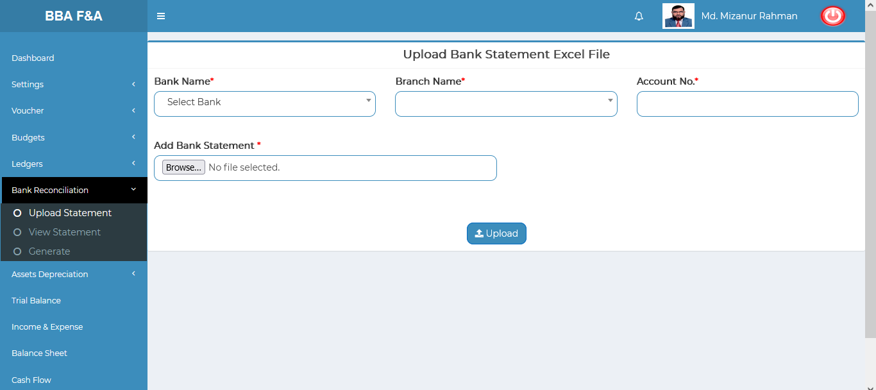

Figure 4.5.1.1: upload bank statement form

### 4.5.2.1: View Statement (Bank Reconciliation) generate bank statement

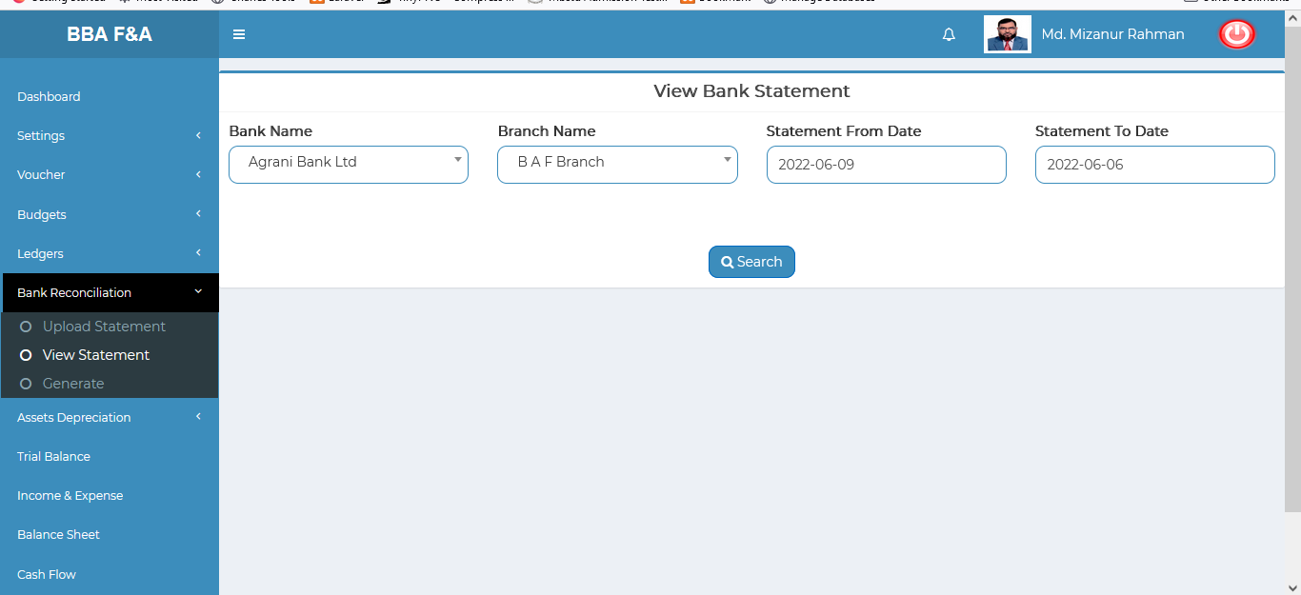

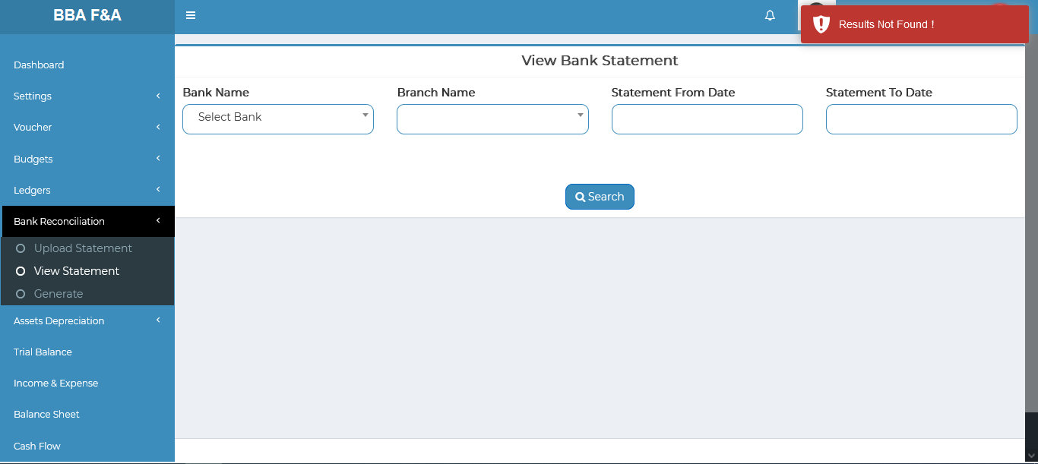

Figure 4.5.2.1: view bank statement

### 4.5.3.1: Generate (Bank Reconciliation) Generating bank reconciliation

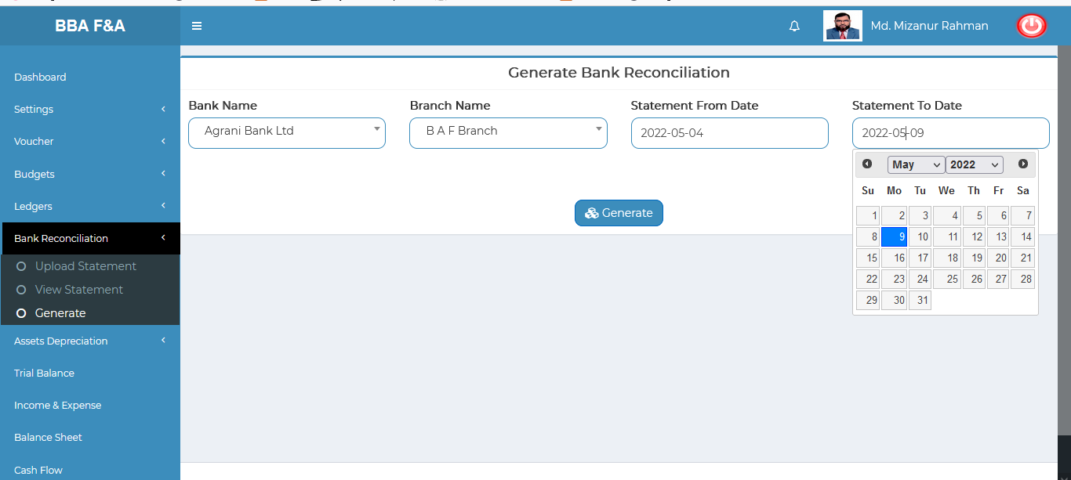

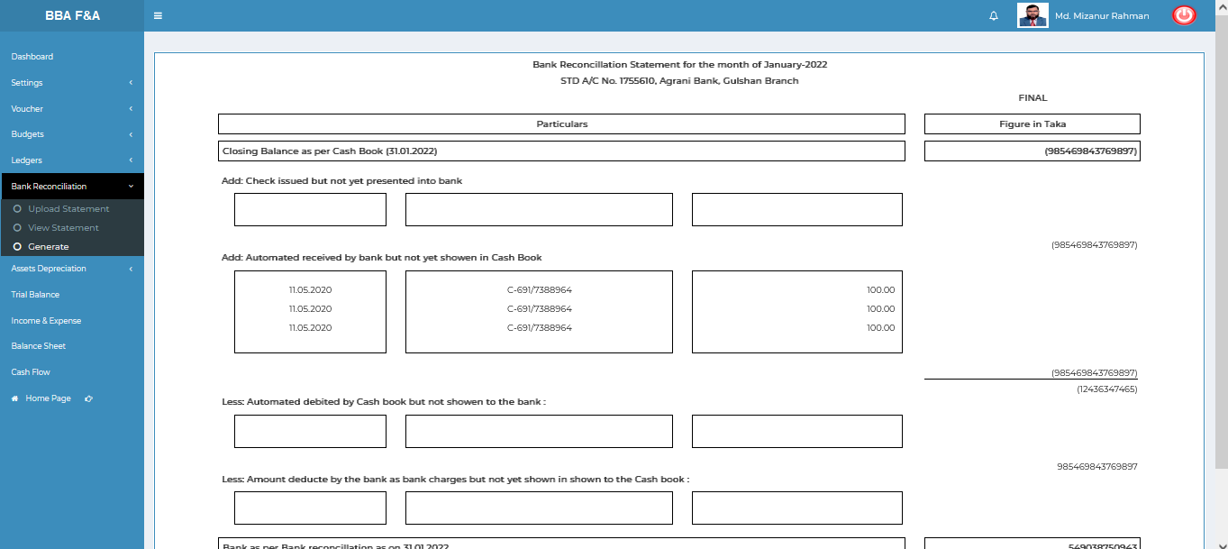

Figure 4.5.3.1: Generating bank reconciliation input form & output

## 4.6: Assets Depreciation Menu Overview

**Overview of Ledger**

Click on the Assets Depreciation menu after that there will appear two (02) sub-menu & they are **Annexure-A , Annexure-B.**

### 4.6.1.1: Annexure-A (Assets Depreciation) View Annexure-A data

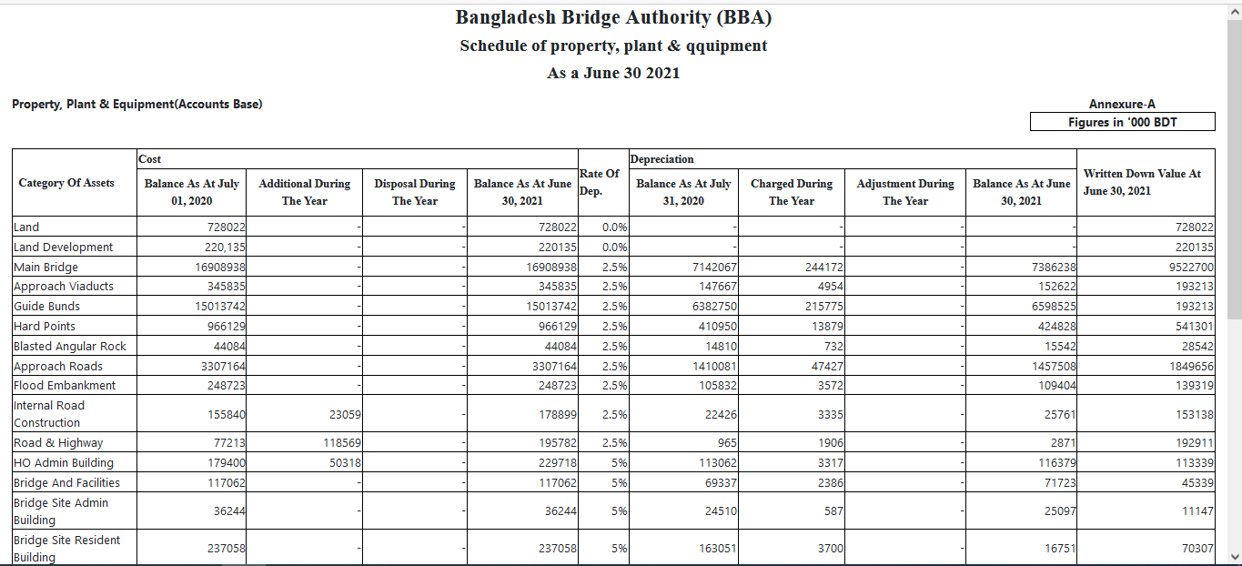

Figure 4.6.1.1: view annexure-a data

### 4.6.2.1: Annexure-B (Assets Depreciation) View Annexure-B data

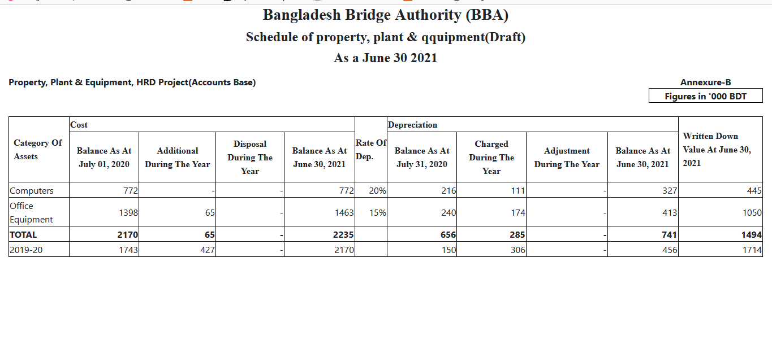

Figure 4.6.2.1: view annexure-b data

## 4.7: Trail Balance Menu Overview

**Overview of Trail Balance**

### 4.7.1.1: (Trail Balance) Trail Balance input form & Result

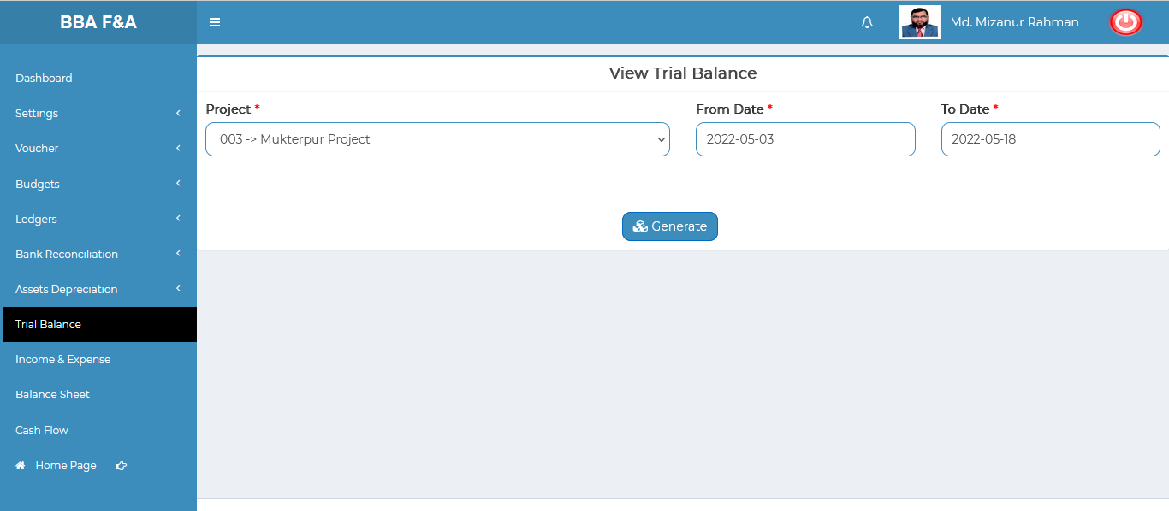

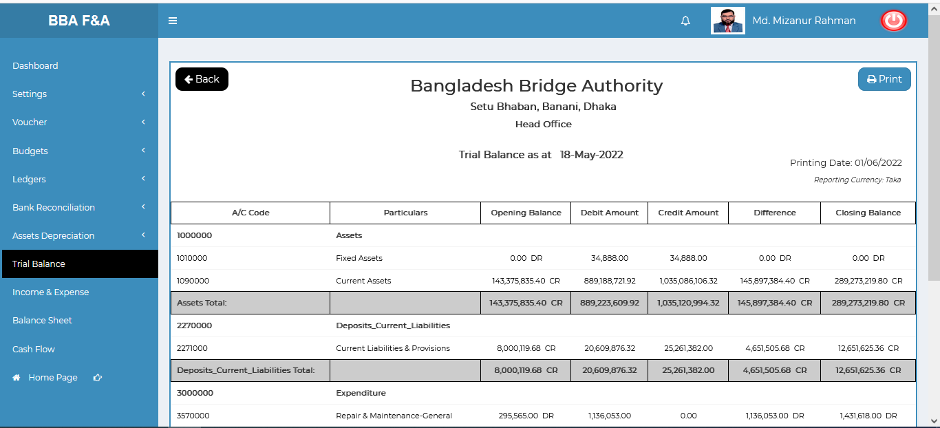

Figure 4.7.1.1: trail balance input form & result

## 4.8: Income & Expense Menu Overview

**Income & Expense Overview**

### 4.8.1.1: (Income & Expense) Income & Expense report generating input form & Result

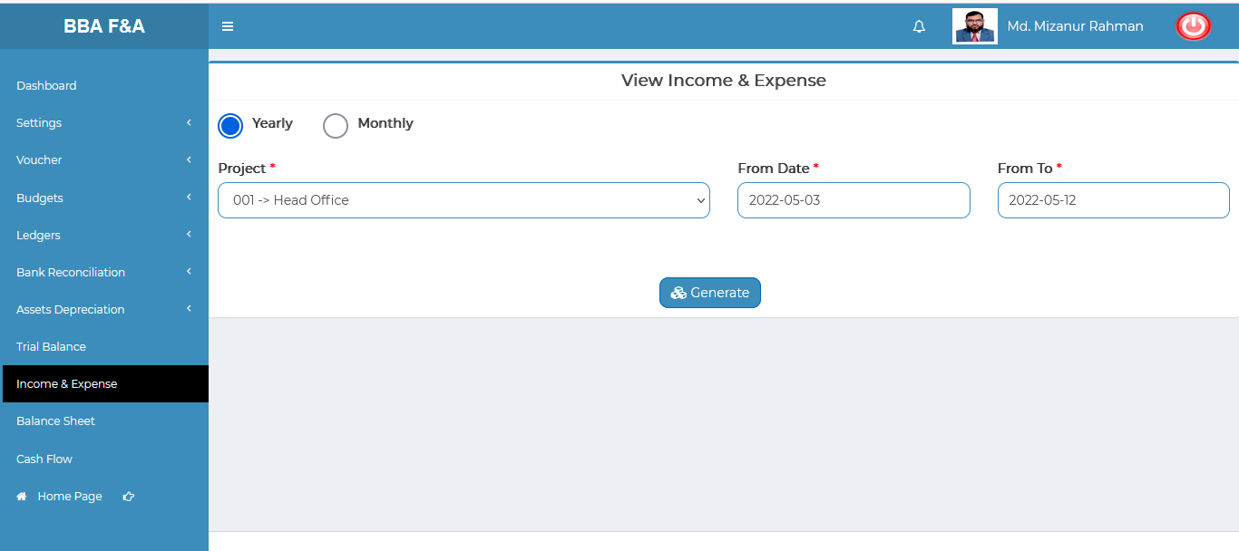

Figure 4.8.1.1: income & expense report generating input form

## 4.9: Balance Sheet Menu Overview

**Balance Sheet Overview**

### 4.9.1.1: (Balance Sheet) Generate balance sheet report input form & result

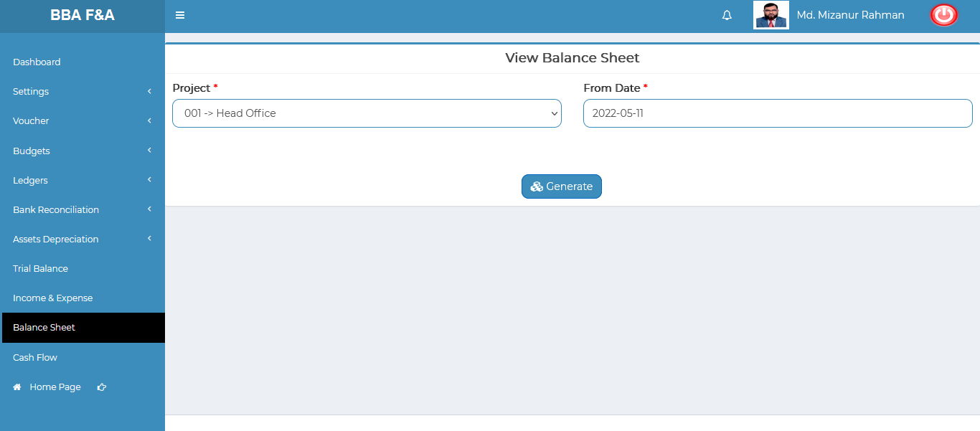

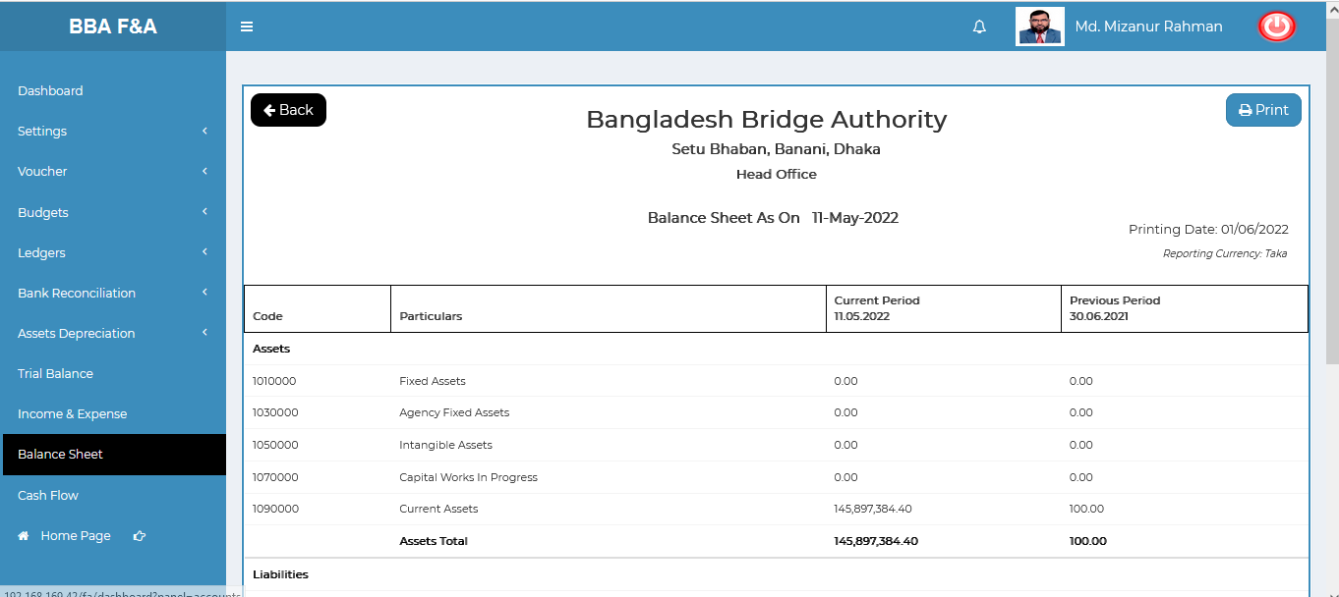

Figure 4.9.1.1: Balance Sheet generator input form & result

## 4.10: Cash Flow Menu Overview

**Cash Flow Overview**

### 4.10.1: (Cash Flow) View cash flow data

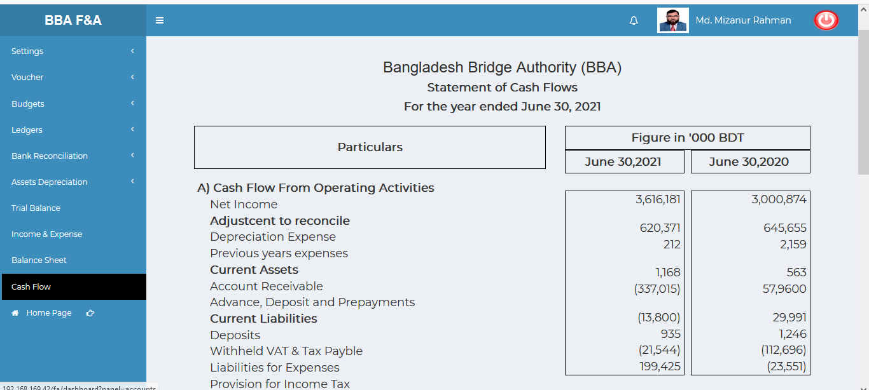

Figure 4.10.1:View cash flow data